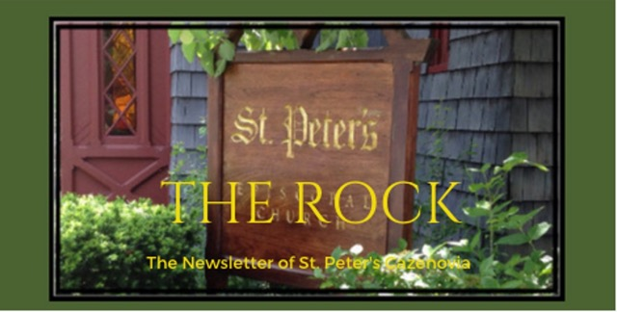

April 2024

Your dead shall live; their bodies shall rise. You who dwell in the dust, awake and sing for joy! For your dew is a dew of light, and the earth will give birth to the dead.

Isaiah 26:19

St. Peter’s News

A Message from our Rector
Alleluia! Christ is risen!
The Lord is risen indeed. Alleluia!

It is on these words that we build our faith. Beloved, it is a privilege to journey through the liturgical seasons with you, but none more so than Eastertide. Easter is the reminder that even in the midst of death, there is life. Easter is the reminder that when things seem their bleakest, there is hope. This is seen clearly in the Gospel of John. Imagine the disciples, huddled together in a room behind locked doors, fearing for their lives and certain that the One in whom they had placed their trust had died a most inglorious death. Imagine their surprise when Jesus appeared in their midst — no phantom, but flesh and blood. “Peace be with you,” he said. Imagine the good news of the Resurrection dispelling their fear, easing their sorrow, renewing their hope. If we let it, the Easter story can do the same for us. We can meet Christ, risen, once again. We can find ourselves renewed, restored, living our lives with the hope that with Christ’s death and Resurrection we, too, have been given new lives. May we meet Christ at the altar every Sunday during Eastertide, and may we as a church be re-figured as Christ’s body each time we share Communion. And may we be empowered to share that good news with others, as we proclaim:

Alleluia! Christ is risen!
The Lord is risen indeed. Alleluia!

Rebecca+

Easter Sunday

So, Jesus, wasn’t that illegal for you to break the seal
the Roman guards put there?

Bursting the bonds of death itself to come again, larger than life? And was it wise to present yourself first to the women,
so lowly in social standing their word meant nothing in court?

And why did you keep appearing suddenly to the huddled believers behind locked doors for
fear of their enemies,
scared out of their wits to hear you say, “Peace be with you!”?

And isn’t it the case that they were never the same again, these ordinary people
who had been so cowed,

receiving your Holy Spirit,

emboldened to begin the work you set in motion,
speaking life and health and peace to all who would listen?

This is what our newborn church looks like: Blessed.
Blessed in our fear and inadequacy. Blessed by your faith in us.

Blessed that we received,
by your own hand, the gift of hope— the beginning of the end of sin and of death.

We follow you as best we can
along that downward path
with all the humility we can manage. You came back to us.
Alleluia.
Alleluia.
Alleluia.
~ By Kate Bowler from her book, Have a Beautiful, Terrible Day!

Easter Sunday is Only the Beginning!

Eastertide is a 50-day long church season, starting on Easter Day and extending until Pentecost. This joyful season is also known as “Easter Season” or “Easter Time”, as well as “Paschaltide”, “Paschal Season” and “Paschal Time.”

The great feast of Easter day celebrates the victory of Christ over death. Eastertide celebrates the time when Jesus rose and walked on Earth for 40 days before ascending to Heaven, and then 10 more days until Pentecost which celebrates the day the church truly became the church. Every Sunday during Eastertide is celebrated as a “little Easter”. The Sunday lectionary readings tell us the stories of post-resurrection appearances of Christ and also give us the promise of a future resurrection. Throughout this season of ancient stories, we can feel the strength and power of our new life in Jesus. This is a season of joy. The color for the season is white. After omitting them during Lent, we bring our alleluias back.

Alleluia! Christ is risen! The Lord is risen indeed, Alleluia!

A Cosmic Ballet

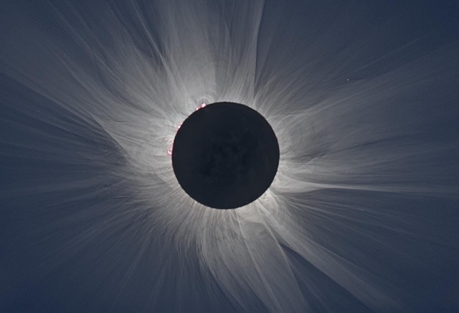

We live in the midst of wonder and mystery and on April 8th will be privileged to experience some of the awe. As Annie Dillard has said, “After the one extravagant gesture of creation in the first place, the universe has continued to deal exclusively in extravagances, flinging intricacies and colossi down aeons of emptiness, heaping profusions on profligacies with ever-fresh vigor!”

In plain words, this annular solar eclipse will happen when the moon passes between the sun and Earth, when it is at or near its farthest point from Earth. Because the Moon is farther away from Earth, it appears smaller than the Sun and does not completely cover the Sun. After the total solar eclipse on April 8, 2024, the next total solar eclipse that can be seen from the contiguous United States will be on August 23, 2044.

But again, the wonder - “In the deep sky where there had been a sun, we saw a ring of white silver; a smoking ring, and all the smokes were silver, too; gauzy, fuming, curling, unbelievable. And who had ever seen the sky this color! Not in the earliest morning or at twilight, never before had we seen or dreamed this strange immortal blue in which a few large stars now sparkled as though for the first time in creation.”

-written by Elizabeth Enwright.

Ministries and Committees

Buildings, Grounds and Gardens

Be sure and look around inside and outside our church. The patio and walkway between the church and the office are being rebuilt, for improved safety and beauty. Our kitchen sparkles after its recent thorough cleaning and new coat of paint. And our nursery is ready to be filled with children during church services and meetings.

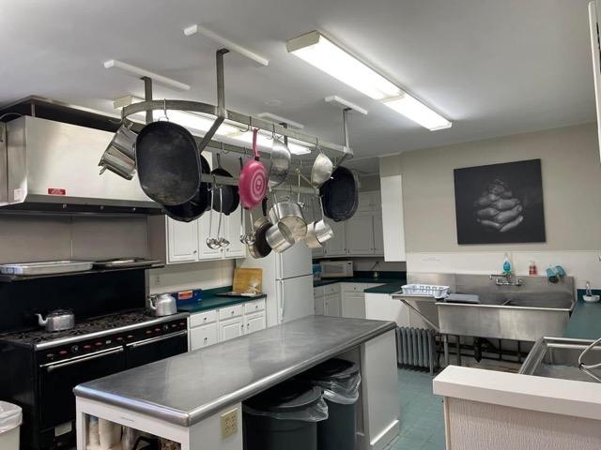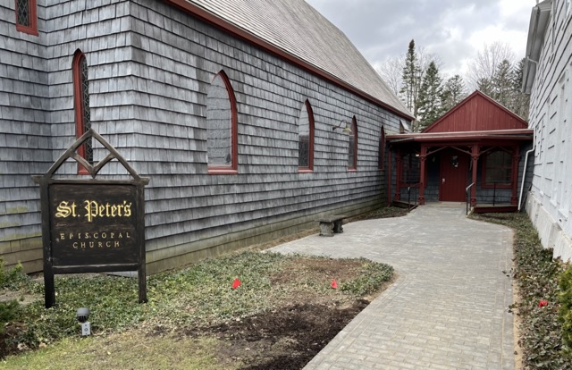

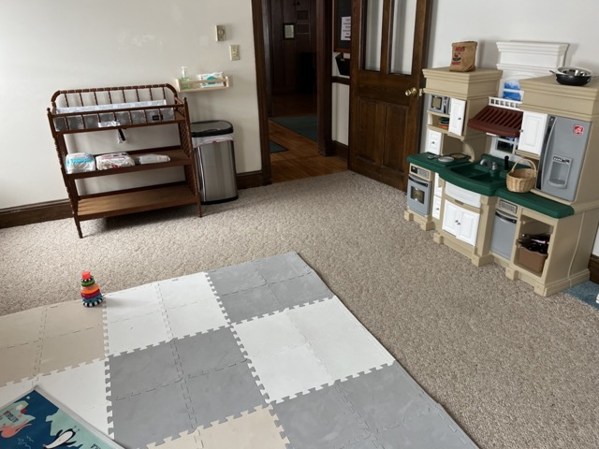

Notes From the Music Gallery

Easter is the celebration of God’s love overcoming darkness and the power of death.

We celebrated Easter morning singing Alleluias, with bells and chamber music selections performed by members of the Syracuse Orchestra string quartet.

Our musicians, adult choir and bell ringers, and Meredith and Betsy worked hard to make the Easter service very special.

On the Second Sunday of Easter, April 7th, bishop DeDe will join us and lead the service along with Rev. Rebecca. We will celebrate the morning with special music by opening the service with “Introit” by Jane Marshall and continuing with Easter hymns. The special anthem will be “Alleluia! Christ is Risen” by Gordon Young. Violinist Edgar Tumajyan and cellist Jacob Bloom will be playing along the choir.

We will have joyous preludes and postludes all through the month, celebrating Easter season. St. Peter’s choir members and musicians, Meredith, Amy and Steve will offer instrumental selections throughout the month.

Our choir is growing, and our rehearsals have been a joy to attend.

Faithfully submitted by Ida
choir director and organist

Members of our Congregation

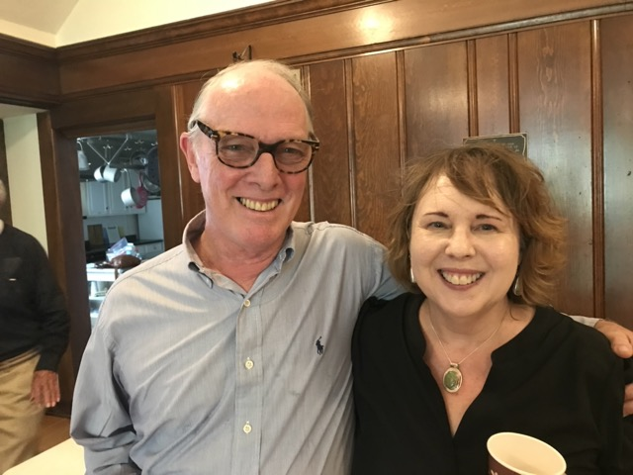
Phil – A Faith Story

This month, The Rock is publishing our first faith story. Thank you, Phil for this new and profound beginning!

My wife June and I, in January 2024, after months of preparation, completed a 1100-mile trek from Montgomery, Alabama to the bucolic hamlet of New Woodstock to begin a new chapter in our life together, within hailing distance of my spiritual home of St. Peter's Episcopal Church in the village of Cazenovia.

In a previous life here, I had lived, worked and, with Winifred, my former wife of twenty-four years, had raised three of her children and one of our own. Winifred was a nursing educator beloved by her children, colleagues and students. In the compass of a week's time, she had passed way from adenoma of the lung and the sudden idiopathic complications of Q fever on Easter Sunday in 2015. I was singing that morning at St. Peter's, and was comforted and consoled by a spiritual community that, to this day, continues to nurture and sustain us.

After Winifred's passing had it not been for the timely intercession of Father Leon Mozeliak, then rector of Grace Church, who, during a chance phone call I placed to him, when she was in the hospital, prayed for me and offered me the sexton's position at the church as a place to land. He provided me with painting work in the parish house, at the decommissioned All Saint's Episcopal Church and later, as a board member of the Diocese of CNY, handed me the keys to what would be one of the most significant projects in my restoration painting career, which was a two-year project restoring the windows and ceiling of St. Paul's Episcopal Church in Paris Center, NY, which was the oldest church in the diocese, dating back to 1818.

At some point during my time at Grace Church, Father Leon inquired whether I had ever contemplated entering into the process of discernment for postulancy in the Episcopal Church. I told him I thought that ship had already sailed, having made a few unfulfilled attempts to "answer calls" that somehow went unanswered.

My father was ordained an Episcopal priest in 1957. He suffered a debilitating attack of M.S. that effectively ended his ministry and changed the course of our life as a family for the next thirty years as we nursed him at home until his death in 1989. He lived long enough to attend my graduation from Yale Divinity School in 1985. I had attended Y.D.S. in the M.Div. program, for 2 years and without the support of my diocese. Much of what I learned of Episcopal liturgical tradition and practice, I acquired experientially through my choral experiences, first as a choirboy, as member of the Kenyon College Choir, singing with oratorio groups and chorales. My experience of the wonder and mystery of faith and spirituality has ever been grounded in the performance of devotional music.

Glimpses of Joy can be found at diverse times and in unexpected places if one is alert to the manifestations of grace in persons and everyday experience. Evidence of this is discovered by way of discernment, a process I have been engaging and contending with much of my life. During my time at Grace, I found another opportunity for joy in a chance acquaintance with my jazz pianist friend, who was serving as an usher. As a sexton, I stood with him at the Choir Door, during services where I joined the congregation singing. Hearing my voice, he invited me to practice with him in the choir room. Soon, he introduced me the joys of singing music from the great American Songbook. He had formerly worked in New York City playing piano at the Drake Hotel. Before long we had formed a group that I named "The Usual Suspects" that included additional vocalists, bass, drums and saxophone. We performed for nursing homes and several well-known venues such as The Kirkland and Remsen Art Centers and Munson. During my time in New Hartford, I continued to maintain my connection with St. Peter's, commuting twice weekly to practice and sing with the choir, as well as attending a healing pilgrim's mass that sustained me during that period of change and uncertainty as to whither I was going and why.

June and I have recently been blessed to have found respite, from the turmoil of romantic misadventures, pandemics and global warming, numerous relocations and storage units, and mean-spirited ecclesiastical wrangling and dissension, in the form of a comfortable house, a barn with tools and a patch of lawn. It is our “maison de reve”, where our collective inspiration and aspirations may flourish. It is a newfound sense of place where June and I may discover anew the unexpected joys of fulfillment in one another, in the affirmations of old and new friendships, in our growing families and the opportunities of exploring new forms of ministry at St. Peter’s and in the wider world we are blessed to inhabit.

written by Phil

News of St. Peter’s and the Greater Community

During April, we are collecting Spaghetti Sauce for CazCares. Thank you for giving so generously!

April will be a busy month for Caz Welcomes Refugees. On April 16th at 6:30, at the First Presbyterian Church, the organization will host a presentation that shares personal stories of re-settlement.

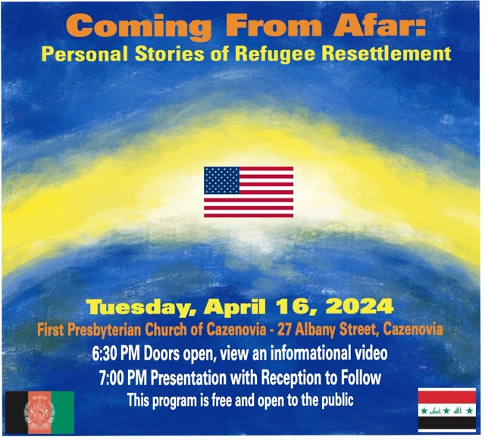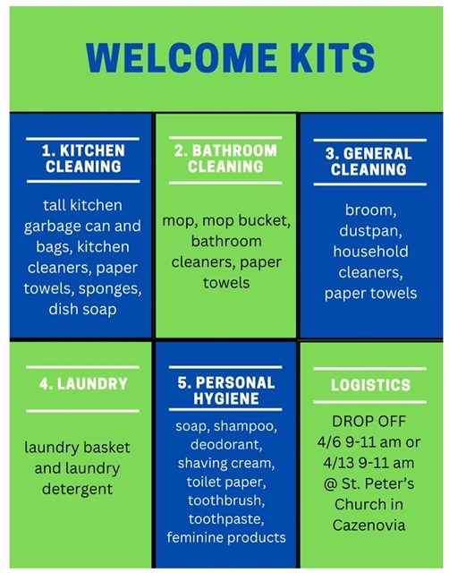

Caz Welcomes Refugees also works with Inter Faith Works to provide furnishings for refugees who live in the wider Syracuse area. For the next few weeks CWR will be collecting items for welcome kits for our new Americans. You may contribute to any of the welcome kits by bringing items to St. Peter’s Church on 2 Saturdays, April 6th and 13th, between 9 and 11:00 AM.

Calendar

Events in April

1 10:00 am Bone Builders
2 9:00 am Bible Study (classroom by Fellows Hall)
3 noon Noonday Prayer with Centering Prayer
4 10:00 am Bone Builders
6:00 pm Healing Service CANCELLED
7:00 pm Choir Practice
7 10:00 am Sunday Service followed by Coffee Hour
8 10:00 am Bone Builders
9 9:00 am Bible Study (classroom by Fellows Hall)
10 noon Noonday Prayer with Centering Prayer
11 10:00 am Bone Builders
7:00 pm Choir Practice
14 10:00 am Sunday Service followed by Coffee Hour
15 10:00 am Bone Builders
16 9:00 am Bible Study (classroom by Fellows Hall)
6:30 pm Personal Stories of Refugee Resettlement (First Presb. Church)
17 noon Noonday Prayer with Centering Prayer
18 10:00 am Bone Builders
7:00 pm Choir Practice
21 10:00 am Sunday Service followed by Coffee Hour
22 10:00 am Bone Builders
23 9:00 am Bible Study (classroom by Fellows Hall)
24 noon Noonday Prayer with Centering Prayer
25 10:00 am Bone Builders
7:00 pm Choir Practice
28 10:00 am Morning Prayer Service followed by Coffee Hour
29 10:00 am Bone Builders
30 9:00 am Bible Study (classroom by Fellows Hall)

1 10:00 am Bone Builders
2 9:00 am Bible Study (classroom by Fellows Hall)
3 noon Noonday Prayer with Centering Prayer
4 10:00 am Bone Builders
6:00 pm Healing Service CANCELLED
7:00 pm Choir Practice
7 10:00 am Sunday Service followed by Coffee Hour
8 10:00 am Bone Builders
9 9:00 am Bible Study (classroom by Fellows Hall)
10 noon Noonday Prayer with Centering Prayer
11 10:00 am Bone Builders
7:00 pm Choir Practice
14 10:00 am Sunday Service followed by Coffee Hour
15 10:00 am Bone Builders
16 9:00 am Bible Study (classroom by Fellows Hall)
6:30 pm Personal Stories of Refugee Resettlement (First Presbyterian Church)
17 noon Noonday Prayer with Centering Prayer
18 10:00 am Bone Builders
7:00 pm Choir Practice
21 10:00 am Sunday Service followed by Coffee Hour
22 10:00 am Bone Builders
23 9:00 am Bible Study (classroom by Fellows Hall)
24

__________________________________________________________________________________________

Copyright © 2024 St. Peter’s Episcopal Church, all rights reserved

Our mailing address is:
St. Peter’s Episcopal Church
10 Mill Street
Cazenovia, NY 13035
315-655-9063

Email us at:
parishoffice@stpeterscaz.org
Find us at:
www.stpterscaz.org

