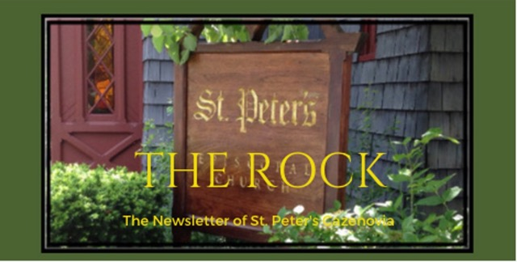

August 2023

St. Peter’s News

A Message from our Rector

Dear Beloved of St. Peter’s,

Happy August! There is something about this month that feels like an intermission — a time between the activities of summer and the hectic pace of fall. This is a month during which many of us try to squeeze in one last trip or we intentionally stay home to savor these last days of summertime. I believe that we can all feel the fall beckoning us forward and we want to stay in this in-between place of sun and warmth and blue skies just a bit longer. August is a time when we long for lazy days, and I have been thinking about what it means to give ourselves permission to rest.

There are many examples in the gospels of times when Jesus and the disciples withdrew to a quiet place. One of my favorite verses is short, to the point, and captures the feeling that so many of us experience in our lives today: “Then, because so many people were coming and going that they [Jesus and the disciples] did not even have a chance to eat, [Jesus] said to them, “Come with me by yourselves to a quiet place and get some rest’” (Mark 6:31, NIV). That is what our bodies and souls need — a place of quiet and time to rest. In a world that is frantic with activity, it is restorative to just be, and this is especially so in nature.

August is also a time when the woods call to us to come in and explore, knowing that the snowy days are not too far away. We are blessed with so many wonderful places to hike in our area, and Brad and I have found joy this summer in getting out and exploring them. The Holy Hikes we have been sharing with Christ Church, Manlius, have been a great way to share the experience of God’s creation, the cathedral of the forest, and to meet new people. Being among the trees has always given me joy and provided a place of restoration. What is your favorite place to rest? Where do you go to reconnect with God and to let your body and heart be restored? My prayer is that you find time to be in that place soon.

The poet, Mary Oliver, knew about “paying attention, being astonished, and telling about it.” The natural world provided fodder for her creativity, and she captured those experiences so well in her works. During the coming month, I invite you to rest, to notice what quiet places offer renewal for you, and I look forward to hearing about it. May you be inspired by these words of Mary Oliver, to go easy… and to shine.

Peace and love,
Rebecca+

When I am among the trees by Mary Oliver

When I am among the trees,
especially the willows and the honey locust,
equally the beech, the oaks, and the pines,
they give off such hints of gladness.
I would almost say that they save me, and daily.

I am so distant from the hope of myself,
in which I have goodness, and discernment,
and never hurry through the world
but walk slowly, and bow often.

Around me the trees stir in their leaves
and call out, “Stay awhile.”
The light flows from their branches.

And they call again, “It’s simple,” they say,
“and you too have come
into the world to do this, to go easy, to be filled
with light, and to shine.”

Members of our Congregation

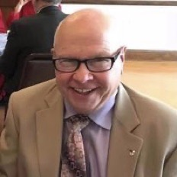

Rick
Rick is a very active member of our church. You can see him as an usher, reader, pancake flipper, volunteer at the Friendship Inn, all-round enthusiastic participator and leader in so many church events that it’s not surprising that he would extend his ministry beyond St. Peter’s. But it is amazing that he has the time and energy to pursue so much. Below, he describes one such pursuit in his own words, his involvement in Syracuse’s Honor Flight.

Last April, I was honored to be a staff member for Honor Flight Mission 19. Honor Flight is a national program where veterans from all of America's wars are given the opportunity, at no cost to them, to visit the memorial pertaining to the war they served in. Currently, most of the veterans chosen for Honor Flight are Korean war vets. However, we had one WWII veteran. Syracuse Honor Flight is about 10 years old and normally has two missions per year. Each mission is a one-day trip to Washington. The mission I served on had 80 veterans, each accompanied by a guardian, along with eight nurses and about 30 of staff members.
As the Chaplain for Ca. Post 88 of the American Legion, I offered a prayer before take-off. I then did my duty as a bus monitor on one of the 4 buses. My job, mainly, was to make sure that everyone riding my bus returned to it after stopping at each site on the tour.
We visited the war memorials as well as the memorial for the Navy, Army and Marines (the Air Force memorial is still under construction). Normally, the tour ends with a visit to Arlington Cemetery and the viewing of the changing of the guard at the Tomb of the Unknown Soldier. However, it started to rain, so this was canceled.
As a side note, local photographer Gene Gisson started a program call Flags of Our Heroes. Because Honor Flight is for the living, he began soliciting photographs of veterans who have died. He takes the photos to the memorials pertaining to their war where he sets the pictures up on an easel and takes a picture of the picture. Then, about three weeks after Honor Flight, family members of the deceased are invited to a ceremony at the War Memorial in Syracuse, where a packet is presented to them. Gene and Post 88, along with Honor Flight members, have been doing this for about 6 years now. I have had the privilege of acting as the Chaplain for this service as well. And, to be honest, I much prefer this ceremony.
Written by Rick

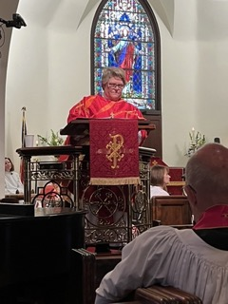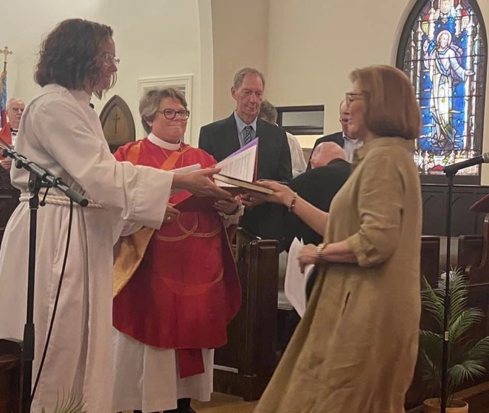

What a joyous celebration!

We all want to remember and cherish this good day - the day of The Celebration of a New Ministry of Rev. Rebecca as our new rector. It was a celebration of the diligent work of our vestry and search committee to find and call the right person to lead St. Peter’s, and of the calling from God that Rebecca answered to come here to us! Most of all, this night was a celebration of the shared ministry of the people of St. Peter’s, Rev. Rebecca, and God.

Here are some pictures of our wonderful celebration.

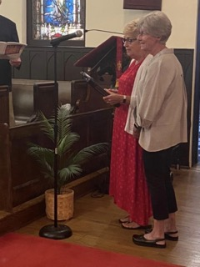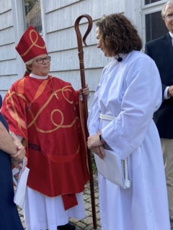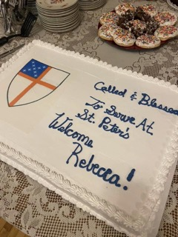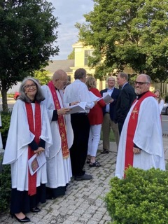

Bible 101 Summer Reading Group

There is one more book to read and discuss in St. Peter’s Summer Reading Group and it should prove to be inspiring! Our next book is Inspired by Rachel Held Evans who wrote as renewed and very spirited Christian.
We will meet on Wednesday, August 24th, at 6:00 in the Small Group meeting room. Snacks and beverages will be provided.
Please contact Rev. Rebecca with questions.

Ministries and Committees

Greetings from the Vestry!

The Vestry met on July 19. Each meeting we hear a report from Rebecca and my goodness, she is busy and took some well-deserved time off in late July and will do so again in August.

We continue to welcome new people as well as welcome back people who are returning. Continue to share the Good News!

We are looking at saving management fees by changing the managers for our endowment fund. This is part of our on-going efforts to try to bring our cash flow (what we bring in each month and what we spend each month) into balance and, as time goes on, even into the black so that we can ADD to our endowment fund and ADDRESS some long-standing capital projects such as painting the exterior of the white building which houses the Rector’s office, the library etc.

Please continue to think and pray about our commitments to this community and our responsibility to steward the church and its properties.

Thank you!
Cynthia Maxwell Curtin,
Senior Warden

News of St. Peter’s and the Greater Community

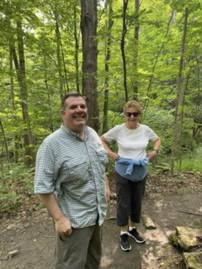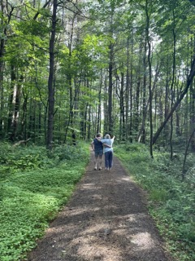

August Holy Hikes

Holy hikes have been a wonderful time of fellowship and renewal among members of St. Peter’s Church and Christ Church, Manlius. These hikes will continue in August, taking place every other Saturday at 9:00. On August 12th we’ll at the trailhead of the Labrador Hallow Nature Trail. On the 26th, we will hike at Chittenango Falls.

August is Soup month in our collection cycle. Please give generously! When these beautiful, hot summer days are over, many people will be grateful to be able to enjoy a bowl of hot soup. Please put soup cans and below listed school supplies in the basket in the parish hall. Thank you so much for your ongoing generosity!

New School Supplies Needed

Pens
Pencils (#2)
Notebook paper
Highlighters
Folders in various colors
Large spiral notebooks
Composition notebooks
Three ring binders
Backpacks

Diocesan News

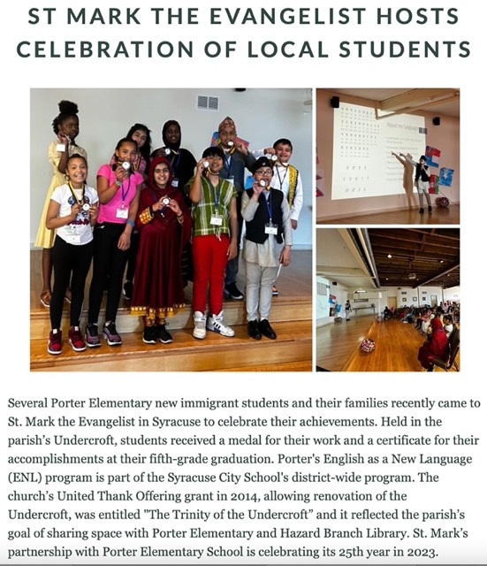

Calendar

Events in August

3 10:00 am Bone Builders (Parish Hall)
6 10:00 am Service Morning Prayer Service led by Don followed by Coffee Hour
7 10:00 am Bone Builders (Parish Hall)
10 10:00 am Bone Builders (Parish Hall)
12 9:00 am Holy Hike at Labrador Hallows Nature Trail
13 10:00 am Sunday Service, followed by Coffee Hour (Parish Hall)
14 10:00 am Bone Builders (Parish Hall)
5:00 pm Volunteer Day at the Friendship Inn
7:00 pm AA Meeting (Parish Hall)
17 10:00 am Bone Builders (Parish Hall)
20 10:00 am Sunday Service, followed by Coffee Hour (Parish Hall)
21 10:00 am Bone Builders (Parish Hall)
24 10:00 am Bone Builders (Parish Hall)
26 9:00 am Holy Hike at Chittenango Falls
27 10:00 am Sunday Service, followed by Coffee Hour (Parish Hall)
28 10:00 am Bone Builders (Parish Hall)
30 6:00 pm Bible 101 Summer Reading Group (Small Group meeting room)

__________________________________________________________________________________________

Copyright © 2023 St. Peter’s Episcopal Church, all rights reserved

Our mailing address is:
St. Peter’s Episcopal Church
10 Mill Street
Cazenovia, NY 13035
315-655-9063

Email us at:
parishoffice@stpeterscaz.org
Find us at:
www.stpterscaz.org

