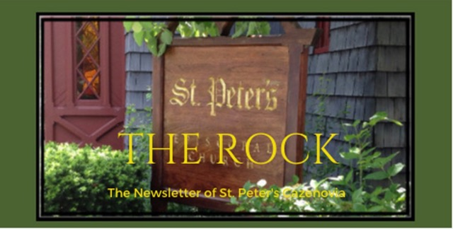

**December 2023**

**Lord, Lord, open unto me**

**Open unto me, light for my darkness.**

**Open unto me, courage for my fear.**

**Open unto me, hope for my despair.**

**Open unto me, peace for my turmoil.**

**Open unto me, joy for my sorrow.**

**Open unto me, strength for my weakness.**

**Open unto me, wisdom for my confession.**

**Open unto me, forgiveness for my sins.**

**Open unto me, love for my hates.**

**Open unto me, thy Self for my self.**

**Lord, Lord, open unto me! Amen.**

**Howard Thurman**

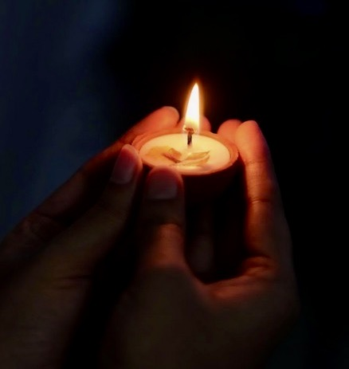

St. Peter’s News

**A Message from our Rector**

Beloved of St. Peter’s,

Here at the beginning of December, it feels as if we are poised to enter a month of juxtapositions. We begin the month with Advent, the Church’s new year, and close the month with the turning of the secular new year. We celebrate the birth of Jesus Christ, the Light of the World, just a few days after the winter solstice, the longest night of the year. To complicate things a bit more, the Fourth Sunday of Advent and Christmas Eve are the same day. Perhaps, this year, it makes sense that we hold the light and the dark so closely together. These can feel like dark times (and not only because the sun dips below the horizon by 5:00 pm) — the sadness of loss, the uncertainty of the world, the worries about unmet expectations, can all seem magnified by the glow of twinkle lights. We say to ourselves, “Isn’t this supposed to be the most wonderful time of the year?” while berating ourselves if it isn’t. Here is the truth of this season, it is a time of joy and sorrow, of celebration and repentance, of already and not-yet. We look ahead to the coming of Christ in glory as we both look back at, and forward to, his birth in a little village in a war-torn portion of the world. Because we acknowledge the truth of our messy and beautiful lives, St. Peter’s is providing opportunities to name our grief. Our monthly healing service will take place on December 7 at 6:00 pm; the Longest Night service on December 21 at 6:00 pm is a space where tears are welcome. Right alongside the solemnity of these services, we have spaces for joy — Celebration Sunday is December 3rd, with a catered brunch following the service; Advent Lessons & Carols on December 17 at 10:00 am will be replete with beautiful music and meaningful scripture; and our Christmas Eve service at 7:00 pm, followed by Contemplative Christmas at 10:00 am on Christmas Day give us a place to revel in the miracle of the season, the Incarnation. Whether your heart is heavy or light or somewhere in between, you are welcome. There is, as always, a place for you — the real you — here.

Advent blessings & so much more,

Rebecca+

**Advent and Christmas Special Services**

On Celebration Sunday, **December 3,** we will turn in pledge cards during the service and then gather for a special brunch.

Thank you for who you are and what you bring to this church community.

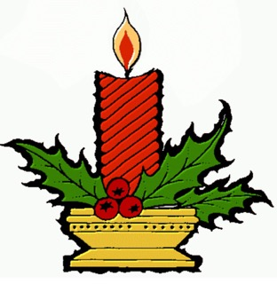

**December 7**: Healing Service, 6 pm

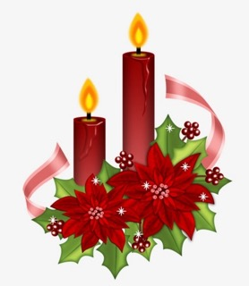

**December 17**: Festive Lessons & Carols, 10 am

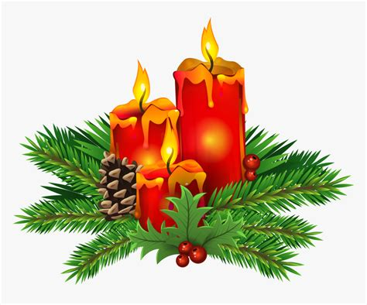

**December 21**: Longest Night (Blue Christmas) Service, 6 pm



**December 24**: Advent IV Sunday Service, 10 am

Christmas Eve Service, 7 pm

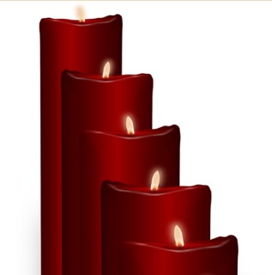

|  |  |  |  |  |  |  |
| --- | --- | --- | --- | --- | --- | --- |
| |  |  |  |  |  |  | | --- | --- | --- | --- | --- | --- | | |  |  |  |  |  | | --- | --- | --- | --- | --- | | |  |  |  |  | | --- | --- | --- | --- | | |  | | --- | | **December 25**: Christmas Day, Contemplative Service,10 am | | |  | | --- | |  | | | | | |

**Light**

Advent is the season on the church year when we prepare for the birth of Jesus Christ. The word “Advent”, from Latin, means “the coming”. For centuries during the Middle Ages, Advent was associated with preparation for the second coming of Christ, and many Christians today still view it as a season to prepare for the second coming.

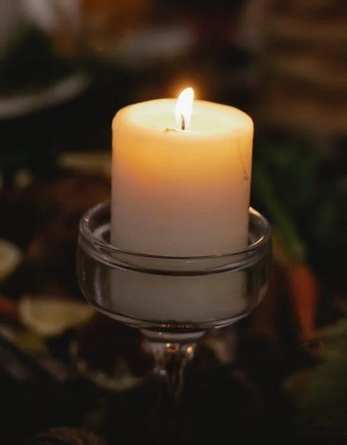

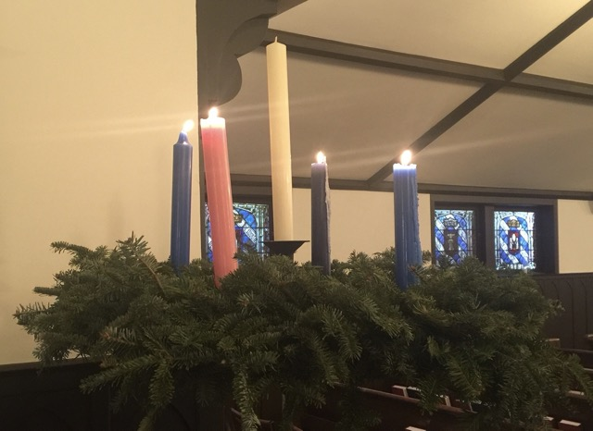

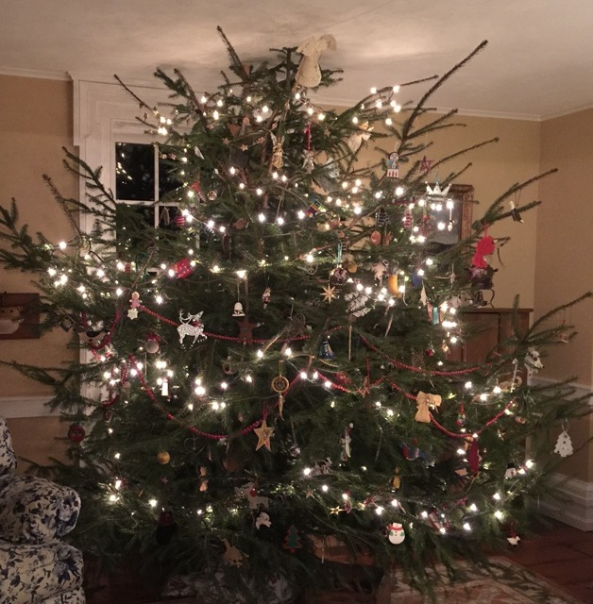

May the candles we light remind us that even in dark times Christ’s light shines, and the darkness cannot overcome it. And may the holy themes we lift up this season remind us that our lives are only complete with the hope, joy, peace and love that Christ provides us.

**Church Field Trip**

**St. Matthew’s Episcopal Church, Moravia, NY**

St. Matthews Church is arguably the most uniquely beautiful church in our Diocese. It was built in the 1820’s, consecrated by Bishop John Henry Hobart, the founder of Hobart College, and is decorated with extraordinary Bavarian Oak carvings. It is near the rustic birth place of Millard Fillmore who was married there.

This dark time that was chosen for Advent corresponds to the dark time when the Israelites waited for the promised Messiah. And we know that there is darkness in the story of Jesus’ birth. We prepare and await the coming of Jesus the Christ, who is the light of the world, by studying, praying, and giving, and by putting up lights.

We Episcopalians especially love the tradition of the Advent wreath. The circle of four candles represents each of the four Sundays of Advent, the fifth candle in the middle stands for Christmas Day. The tradition is to light a new candle each week as we wait and prepare for Christ’s coming on Christmas.

Each Sunday of Advent celebrates a different theme: hope peace joy and love. In reflecting on a new sentiment each week during Advent, we not only brighten our lives but our spirits as well. At the end of our Christmas Eve service, while singing “Silent Night”, we at St. Peter’s kindle each other’s candle until our church is filled with light.

May the candles we light remind us that even in dark times Christ’s light shines, and the darkness cannot overcome it. And may the holy themes we lift up this season remind us that our lives are only complete with the hope, j

Members of our Congregation

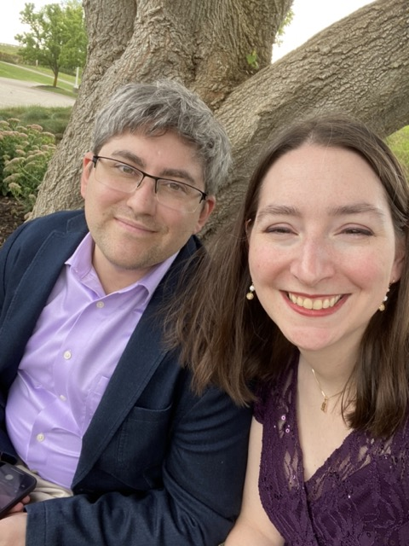

**Meet Will and Michelle**

They’ve just moved to Cazenovia and began attending St. Peter’s in June. Will and Michelle are both originally from the Detroit, Michigan area, although they met on the other side of the state, near Grand Rapids, during college. Prior to the move to Cazenovia, they lived in Pittsburgh, where Will worked toward a PhD in Clinical Psychology and Michelle completed an MA in English. Will’s final year of training—the Predoctoral Internship—is taking place at Upstate Medical University. Michelle was fortunate enough to be able to take her remote job at University of Illinois Press with her.

While in Pittsburgh, Will and Michelle attended Calvary Episcopal Church and were both involved in the Young Adult Ministry. In addition, Will served as an usher and Michelle participated in book club. Since arriving in Caz, they’ve enjoyed getting to know everyone at the church and have been excited to get involved, with Will now learning to be a Lay Eucharistic Minister, and Michelle soon to be an usher-in-training. Michelle also has started volunteering at Carriage Barn Books. Together, they have two cats and enjoy playing board games.

written by Michelle

Ministries and Committees

**Pastoral Care Ministries**

Four times a year, during Advent, Christmas, Lent, and Easter, our congregation gives caring literature and small spiritual items to our church members who may not be able to personally attend services.

Gift to be delivered at the beginning of Advent 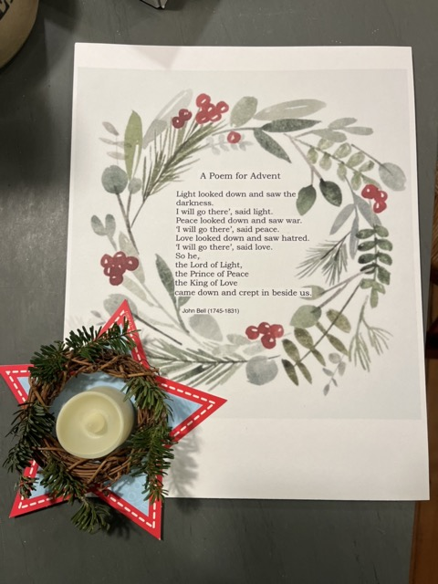

**News from the music gallery**

Advent is upon us and along with it the anticipation of the birth of Jesus and the Celebration of Christmas.

St. Peter’s choir will celebrate the First Sunday in Advent with the special anthem, “Come Thou Long-Expected Jesus”. An aria from the Coffee Cantata by J. Bach will conclude the service and will serve as the prelude of the Coffee Hour Brunch. Joining us will be soprano Katherine Skafidas and our musicians, Amy, Meredith, and Steve.

The Celebration of “Advent Lessons and Carols” will take place during the 10 am Sunday service, December 17th. Joining the Choir will be Beverly and Edgar on violins.

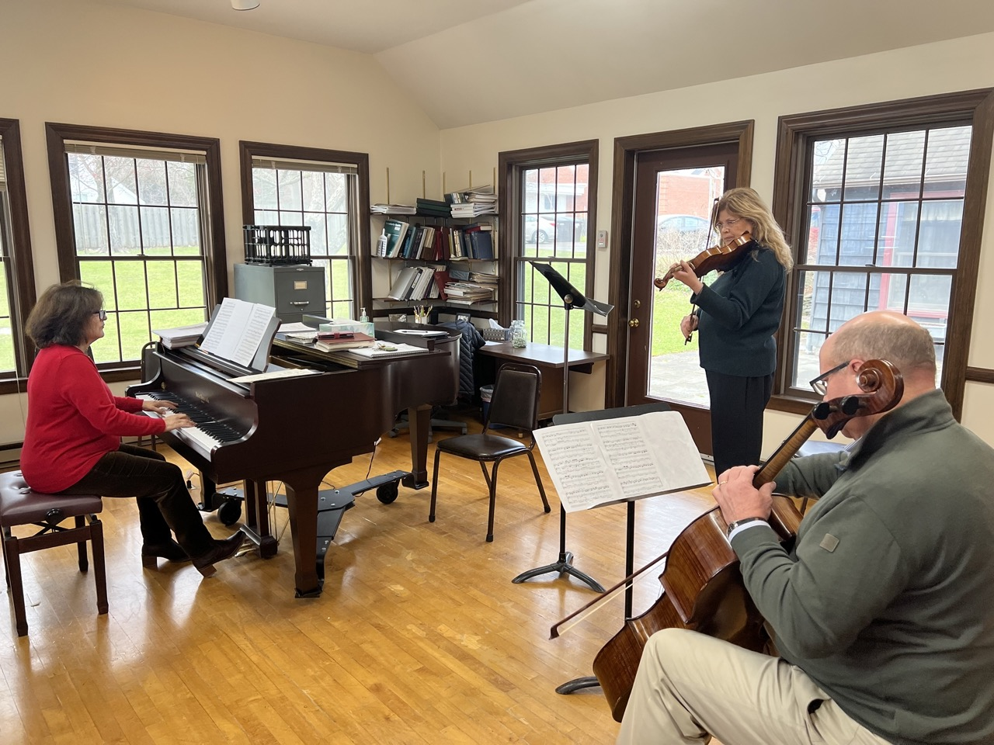

**Rehearsal of the Coffee Sonata**

The Christmas Party for the choir will be on December 16th at Judy’s lovely home. We are looking forward to singing Christmas Carols together.

Christmas Eve Service will be a joyous one with music and Symphoria’s string quartet. Joining us will be soprano Janet as well as Edgar and Jessica, Noemi on violin and Spencer on double bass. Our special music will include “O Holy Night” by Adolphe Adams.

I want to thank our choir members for their dedication and hard work during the season. We also welcome members of the parish to join the choir in singing during the season. Please let, the choir director, on any choir member know if you are interested and available.

Blessings to all,

Ida

**Buildings, Grounds & Gardens**

After much investigation and discussion, the BG&G committee and the vestry determined that removal of the linden tree located by Fellows Hall was necessary, as it was encroaching on the building’s foundation and drainage system. The tree was skillfully removed and further enhancements to this area are being planned.

**Shannon’s Delicious Chocolate Cookies – sooo Christmasy!**

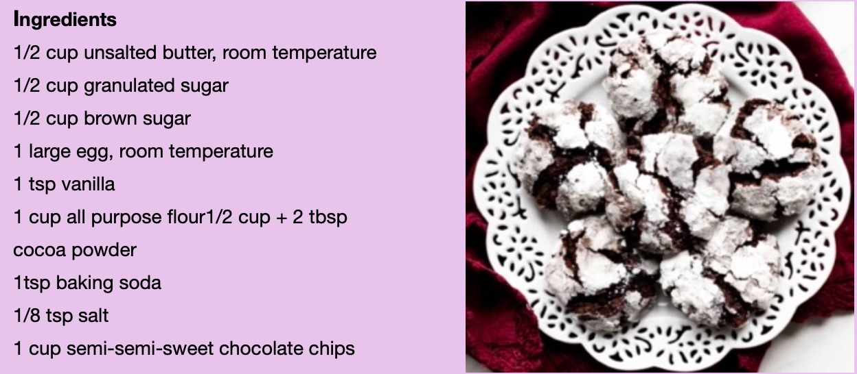

Mix dry ingredients together. You need all-purpose flour, unsweetened cocoa powder, baking soda and salt.

Beat wet ingredients together. You need butter, white sugar, brown sugar, egg and vanilla extract. Room temperature butter and egg will mix more evenly into each other, creating a uniform texture among all the cookies. Additionally, both whip into a greater volume when at room temperature, creating a softer-crumbed cookie.

Combine all ingredients. And don’t forget to add the chocolate chips! I like to use mini size so there’s more in every bite.

Chill the cookie dough in the refrigerator. The cookie dough is sticky and unmanageable, so chilling is necessary. Sometimes I chill it overnight, but 3 hors is perfect. Chilled cookie dough is not only easy to handle and roll into balls, it also bales thicker cookies.

Roll cookie dough into balls. Roll the cookie dough into balls, about 1.5 tablespoons of dough per cookie.

Coat in confectioner’s sugar. Roll the cookie dough balls in granulated sugar, then a hefty dunk in confectioner’s sugar.

Bake. Bake the cookies for 11-12 minutes. If the cookies aren’t really spreading by minute 9, remove them from the oven and lightly bang the baking sheet on the counter 2-3 times. This helps initiate that spread. Return to the oven for a couple more minutes.

**News of St. Peter’s and the Greater Community**



The key is preparing for Christmas season, both outside and inside. There are many great, beautiful, fun seasonal home goods for sale, such as baskets, cookie jars, Santa figurines, and much more. And if you prefer fun seasonal clothing, The Key has that, too.

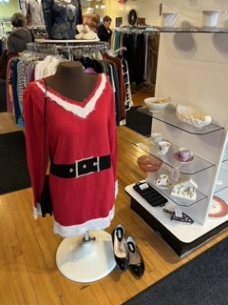 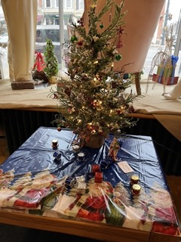 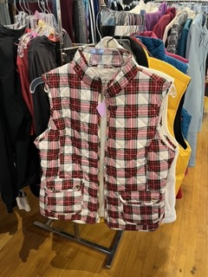



**26% or 1 out of 4 people in Madison County live in poverty!**

This year, Caz Cares distributed Thanksgiving boxes of fresh vegetables, turkey and trimmings for 212 families.

Please donate **Cereal** throughout the month of December by putting it into the Caz Cares basket in the Parish Hall.

**Caz Cares still needs volunteers to distribute Christmas food baskets on Wednesday, December 20th from 9am to noon**. This will be a drive-by event, so dress for the weather. Please call Caz Cares at. 315-655-3174 to volunteer.

**Calendar**

**Events in December**

3 10:00 am Stewardship Celebration Service with special music and brunch

4 10:00 am Bone Builders (Parish Hall)

**5:00 pm Volunteer Day at the Friendship Inn**

8:00 pm   AA Meeting (Parish Hall)

6  noon Noonday Prayer with Centering Prayer

7    10:00 am   Bone Builders (Parish Hall)

**6:00 pm Healing Service**

7:00 pm Choir Practice

10 **10:00 am Advent II Sunday Service followed by Coffee Hour**

11 10:00 am Bone Builders (Parish Hall)

13    noon   Noonday Prayer with Centering Prayer  
14    10:00 am   Bone Builders (Parish Hall)

7:00 pm Choir rehearsal

17 **10:00 am Lessons and Carols followed byt Coffee Hour**

18 10:00 am Bone Builders (Parish Hall)

20    noon   Noonday Prayer with Centering Prayer  
21 10:00 am Bone Builders (Parish Hall)

6:00 pm **Longest Night (Blue Christmas) Service**

7:00 pm   Choir practice

24 10:00 am Advent IV Sunday Service

**7:00 pm Christmas Eve Service**

25 10:00 am **Contemplative Christmas Day Service**

27 noon Noonday Prayer with Centering Prayer

28 10:00 am Bone Builders (Parish Hall)

31 10:00 am Sunday Service followed by Coffee Hour

__________________________________________________________________________________________

*Copyright © 2023 St. Peter’s Episcopal Church, all rights reserved*

Our mailing address is:

St. Peter’s Episcopal Church

10 Mill Street

Cazenovia, NY 13035

315-655-9063

Email us at:

[parishoffice@stpeterscaz.org](mailto:parishoffice@stpeterscaz.org)

Find us at:

www.stpterscaz.org