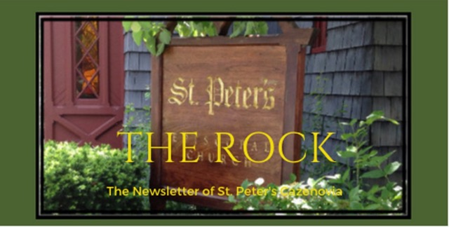

February 2024

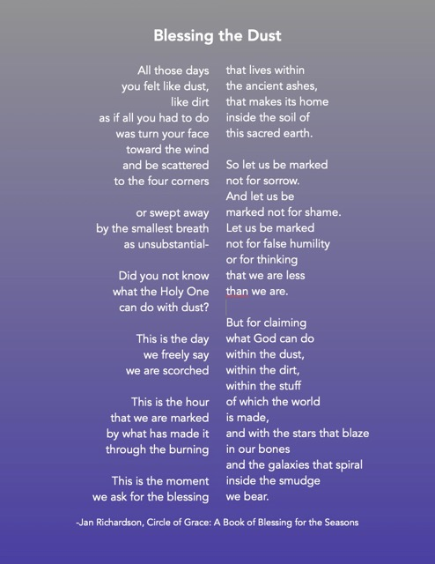

St. Peter’s News

A Message from our Rector
Beloved of St. Peter’s,
Perhaps it is just me, but it feels as if we are speeding through the liturgical year! Here we are at the beginning of February and Lent is right around the corner. This year, Ash Wednesday falls on Valentine’s Day, and the juxtaposition of this day when we remember our mortality and the day when we celebrate love may seem odd. However, I think it’s appropriate. What great love God had for humankind that God became incarnate, suffered, and died as one of us! This is the greatest love and one that we can only glimpse slightly during our limited time on earth. The love of Jesus Christ eclipses any human love — it is that love to which we aspire. Perhaps this year, as our foreheads are smeared with ash and we hear those words “you are dust and to dust you shall return,” we will be convicted to make love our greatest priority. During Lent, we are invited to walk with Jesus toward the cross — perhaps we will also be invited into a deeper love of God and our neighbor.

God’s peace,
Rebecca+

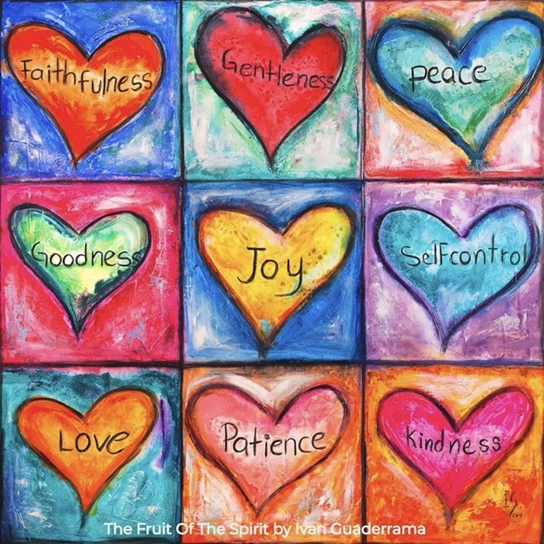

Shrove Tuesday—Ash Wednesday/Valentine’s Day—Lent

Celebrated the day before Ash Wednesday, Shrove Tuesday (also called “Pancake Tuesday” or “Pancake Day”) is the final day before the 40-day period of Lent begins. This year it falls on February 13.
Its name comes from the Germanic-Old English word “shrive,” meaning to absolve, and it is the last day of the liturgical season historically known as Shrovetide. Because it comes directly before Lent, a season of fasting and penitence, this was the day that Christians would go to be “shriven” by their confessor.
Shrove Tuesday also became a day for pre-fasting indulgence. In particular, the need to use up rich ingredients such as butter, milk, sugar and eggs before Lent gave rise to the tradition of eating pancakes on this day.

February 12, 2018, EpiscopalChurch.org

St. Peter’s will host a Shrove Tuesday pancake supper on February 13th at 6 PM in Fellows Hall. All are welcome.

Ash Wednesday is on February 14th this year. There will be two services with Imposition of Ashes at St. Peter’s Church: at noon and 7:00 PM.

The Anglican Compass explains that Christians, during Lent, prepare for the celebration of Easter. This tradition, taking place since ancient times, is patterned after Jesus’ 40-day temptation in the wilderness. Lent is a season of repentance, fasting, and self-reflection. This all happens with our belief that we have God’s grace and love and Lent is not a time of condemnation. The custom of receiving ashes on our heads has signified repentance since biblical times — Job said, “I repent in dust and ashes.”

AnglicanCompass.com

Lenten Formation

Tuesdays @ 9 am.: Bible study where we learn more about the story of St. Paul, his conversion and ministry. All are welcome to attend in the classroom next to Fellows Hall

Beginning after Ash Wednesday:

Tuesdays @ 6:00 pm : Soup Supper & Study of How to Know A Person by David Brooks in Fellows Hall

Sundays after the service: Study of The Difficult Words of Jesus by Amy-Jill Levine in the classroom next to Fellows Hall

On Sunday, February 18th, at our 10:00 AM Sunday service, there will be a Lenten liturgical dance. This will be a collaboration of dance choreographed by Suzanne Evans and music directed by Ida Tili-Trebicka to interpret a bible story for the first Sunday of Lent.

Members of our Congregation

McEwan

McEwan was born in New York but was raised in Florida. He and Deede have been married for over 45 years and had lived in Florida, Georgia, and New Jersey, prior to moving to Hamilton, NY in 1999. In Hamilton, they moved from the Presbyterian Church to the Episcopal Church, joining St. Thomas' Church, where they were confirmed by Bishop Skip Adams. In 2013, they moved to Cazenovia and joined St. Peter’s shortly after. They have three children and three grandchildren.

McEwan works for an architectural and engineering firm and is responsible for a department that provides consulting services on security and safety-related issues. He has worked globally in Critical Infrastructure related security, safety, and risk management design and consultancy services, including solutions for a diverse group of clients including federal and state government clients.

He previously served as a trustee for Cazenovia College, and presently serves on the Board of the Friends of Lorenzo.

He and Deede love Cazenovia and enjoy traveling and hiking as well as spending time with their children and grandchildren. They also love St. Peter's and supporting its work in the community.
Written by McEwan

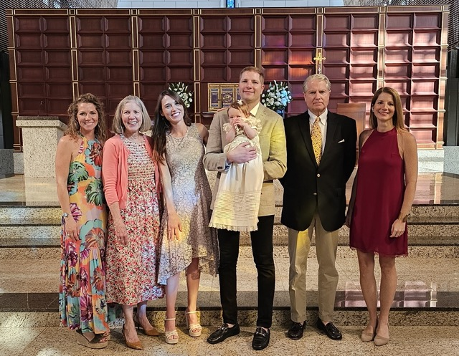

McEwan (2nd from right) and his family at his granddaughter’s baptism. Tis photo combines two of the most important things for McEwan, his family and his faith.

McEwan (2nd from right) and his family at his granddaughter’s baptism. This photo combines two of the most important things for McEwan, his family and his faith.

Ministries and Committees

Greetings from the Vestry!

The Vestry met on January 17th and is happy to report that St. Peter’s Christmas services were attended by over 180 people all in all.

Our endowment was transferred to the Episcopal Church Foundation who will manage it in conjunction with St. Peter’s. Unlike our previous firm, the Foundation offers church specific support as well as a slightly lower management fee.
Our end-of-year deficit is lower than originally projected while at the same time budget pledges for 2024 exceeded our expectations.

We have made progress on our plans for the courtyard area to improve drainage and replace the pavers to create a safe walking area.

We lost our oldest church member, Helen Stacy, who passed away at the age of 103. Funeral plans are being arranged.

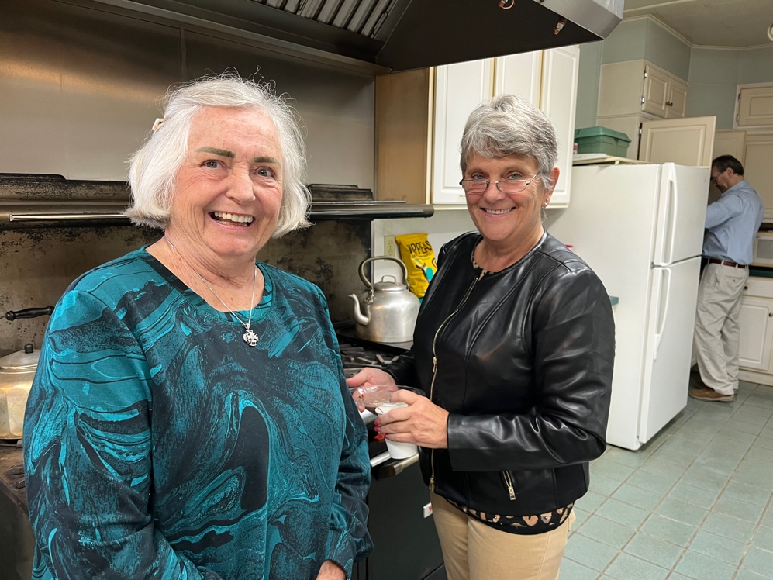

Hospitality (Coffee) Hour

After a lingering hiatus following our Covid shut down, limited coffee hour refreshments, and a lull in volunteer hosts, we most happily report that our Sunday coffee hour, aka the Eighth Sacrament, is operating well again!

Lorie, Sarah, Diane, and Louise have organized a simple system that encourages volunteer hosts, and supplies regular and decaffeinated coffee, sweeteners, half and half, and the necessary paper supplies. Many of our church family members have stepped up to host. We greatly thank each one! Special and most profound thanks go to Stephanie and Lorie who have recently spent hours cleaning and reorganizing the kitchen!

News from the Music Gallery

Notes on Music

February is an important month in our church life as we transition from Epiphany to Lent. On February 14th, with quiet music, we will open the season of Lent during our Ash Wednesday services. On February 18th, the first Sunday in Lent, the service will begin with a Liturgical Dance beautifully choreographed by the one and only Suzanne Evans, and will feature some of the students in her dance studio.

St. Peter’s musicians will provide the special music for the occasion, an Aria from Mendelssohn's "Three church Motets". We have a repertoire great music especially chosen to complement each Sunday’s readings during Lent.

Some new and happy notes: Winnie, a soprano, has joined us and we are delighted for her service to the church and for hearing her beautiful voice on Sundays. Welcome, Winnie!
Also, our chorister friend Phil has returned to the area with his wife June, and has rejoined the tenor section of our choir. Welcome home, Phil and June! We love having you all!

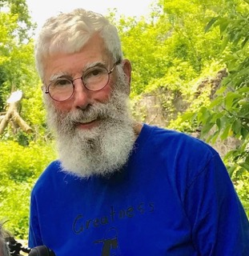

Introducing our Choir—one Member at a Time

“You should join the choir,” she said, completely without reason or sense over a cup of coffee on our first Sunday attending St. Peter’s. “OK,” I replied, pleased that Judy favored the forest more than an unknown tree, “when do you rehearse?” Of course, she didn’t know it, but, apparently, I was an easy target, even early on.

I do remember, when as a young child, being in choir robes in a community church’s children’s choir long before I had any clue why. And I remember, later, auditioning at St. Thomas’ Choir School in Manhattan, although an incipient changing voice saved me from that! But probably it was my three years in a primary (Episcopal boarding) school that shaped me the most; Compline every evening (or was it evensong?), and school plays captured me. See photo below. I’m there!

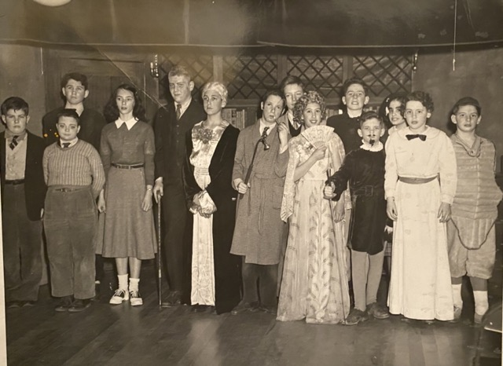

The theme persisted during summers when the Drama Club captured my parents and, out of convenience, me. In high school, theater ruled (as did football, track, and, of course daily chapel, for this too was an Episcopal school)! And for a couple of summers, Summer Stock drew me to where I could focus on learning what I could about stage lighting.

The theme persisted in College where I shied away from the chapel but joined John Henry Day’s choir at Trinity Church, Geneva, took as many theater courses as I could, and, wary of the clutches of the theater muse, trod the boards but once!

Of course, once ordained, and rector of, eventually, four parishes, and while serving on the bishops’ peripatetic staff, I could never be a regular member of a choir and so missed the camaraderie forged in trying to perfect anthems for Sunday mornings.

The above may help to explain why an otherwise well balanced person should impulsively fall under the spell of a compelling coffee swilling soprano (or alto - I just don’t remember), and, putting reason aside, throw in his lot with Ida and company!

Written by Alan

Sound Journey  Presented by  Leigh Parry-Benedict  February 25 @ 3PM  St. Peter’s Episcopal Church  Admission: $15  Cash or Venmo | Participants will be immersed in the healing vibrations of Celestial Gong, Tibetan singing bowls, Alchemy and frosted singing bowls, Native American flute, Shamanic drum and tongue drum. You may choose to sit or lay down on your yoga mat, towel or blanket while receiving the healing sounds. The sound journey is a meditative experience and gives you many of the same benefits of a physical yoga practice and can help lower blood pressure, reduce stress and anxiety and help increase you overall feeling of well-being.

News of St. Peter’s and the Greater Community

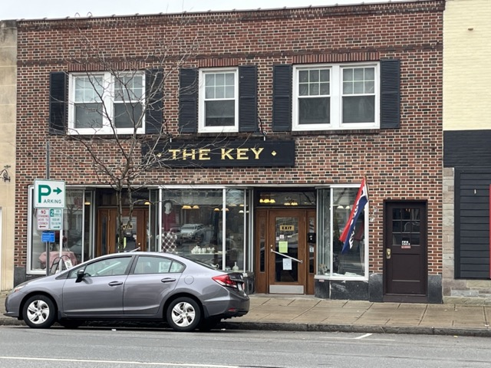

Still doing business right on Albany Street

Dolli’s report for The Key reiterates what was reported in our annual report. Due to a lack of volunteers and staffing, decreased interest into storefront consignment shopping, and overall budget issues, our ministry of The Key will be ending at some point in the next year. A listening session about the future of The Key will be held in Fellows Hall after the Sunday service on February 11.

In the meantime, please consider doing a little more shopping at the Key. There are amazing bargains in clothing and housewares.

February is Soup month in our CazCares collection cycle. Please give generously! We all know how good it feels to come inside from the cold and warm up with a bowl of hot soup. Please put soup cans in the basket in the parish hall. Thank you so much for your ongoing generosity!

During food-centered holidays like Thanksgiving and Christmas, food pantries receive a lot of attention. At those times, people are incredibly generous and thoughtful about their giving. However, having sufficient food is not just about having the money for a big turkey or ham during the holidays. The reality is that many families have a continual need for food throughout the year. They are regularly skipping meals, going to bed hungry and worried about being able to buy food.
Hunger and food insecurity exist in our area — 10.4% of the residents in Madison County live in poverty (according to the 2022 Census). CazCares Food Pantry addresses this need every day.

The specific issues that bring people to CazCares are complex and varied:
A family with small children may have one hourly wage earner. They may come to CazCares to find clothing for their growing children. Elderly residents living on a fixed income often find their savings decreased by the cost of maintaining and heating their home. With the price of groceries increasing, their limited food budget is stretched thin. Receiving food at the pantry helps reduce this serious concern. When the primary wage earner is unable to work, an entire family is affected. The food assistance they receive makes the difference between going hungry and feeding the family.

One misconception about poverty and hunger is that those living in poverty don’t care and don’t work hard enough. That is not usually the case. When families are living so close to the edge, challenges such as car repairs, high heating bills, or days missed from work cause the entire household to struggle. People are not living in poverty because they aren’t working, it is more likely an accumulation of these normal life situations and the ability to react to them at the time. The fact remains that there are families that face many challenges and need community support.

As Reverend Rebecca reminds us, Christ taught that the poor would always be with us. Rather than giving us an excuse to turn away from their needs, this means that we are always called to care for those on the margins. As Christians, we are taught to take care of less fortunate and to show kindness to others. The families who visit CazCares are under constant stress and dealing with numerous life issues. The kindness shared by a friendly greeting, helping people choose clothing for their children, and providing groceries show that we care. Sometimes listening with thoughtful interest is enough to raise their spirits.

St. Peter’s has had a strong association with CazCares since its inception and until this day. Your support is displayed each time you donate food or clothing, give of your time, purchase Christmas gifts or provide financial assistance. On behalf of the families we serve, thank you for your continued generosity.

Calendar

Events in February
1 10:00 am Bone Builders (Fellows Hall)
6:00 pm Healing Service with Communion
7:00 pm Choir Practice
4 10:00 am Sunday Service followed by Coffee Hour (Fellows Hall)
5 10:00 am Bone Builders (Fellows Hall)
5:00 pm Volunteer Day at the Friendship Inn
7:00 pm AA Meeting
6 9:00 am Bible Study on the Life of the Apostle Paul (classroom by Fellows Hall)
7 noon Noonday Prayer with Centering Prayer
8 10:00 am Bone Builders (Fellows Hall)
7:00 pm Choir Rehearsal
11 10:00 am Sunday Service followed by Coffee Hour (Fellows Hall) and
Listening Session about the future of The Key
12 10:00 am Bone Builders (Fellows Hall)
13 9:00 am Bible Study on the Life of the Apostle Paul (classroom by Fellows Hall)
6:00 pm Shrove Tuesday Pancake Supper (Fellows Hall)
14 10:00 am Bone Builders (Fellows Hall)
noon Ash Wednesday Service with the Imposition of Ashes
7:00 pm Ash Wednesday Service with the Imposition of Ashes
15 10:00 am Bone Builders (Fellows Hall)
7:00 pm Choir Practice
18 10:00 am Sunday Service with Liturgical Dance followed by Coffee Hour (Fellows Hall) and
Study of The Difficult Words of Jesus by Amy-Jill Levine (classroom next to
Fellows Hall)
19 10:00 am OFFICE CLOSED for Presidents’ Day
20 9:00 am Bible Study on the Life of the Apostle Paul (classroom by Fellows Hall)
21 noon Noonday Prayer with Centering Prayer
6:00 pm Soup Supper & Study of How to Know A Person by David Brooks (Fellows Hall)
22 10:00 am Bone Builders (Fellows Hall)
7:00 pm Choir Practice
25 10:00 am Sunday Service followed by Coffee Hour Parish Hall) and Study of The Difficult
Words of Jesus by Amy-Jill Levine (classroom next to Fellows Hall)
3:00 pm Sound Journey with Leigh Parry-Benedict
26 10:00 am Bone Builders (Fellows Hall)
27 9:00 am Bible Study on the Life of the Apostle Paul (classroom by Fellows Hall)
28 noon Noonday Prayer with Centering Prayer
6:00 pm Soup Supper & Study of How to Know A Person by David Brooks (Fellows Hall)
29 10:00 am Bone Builders (Fellows Hall)
7:00 pm Choir Rehearsal

Ss. Peter and John Episcopal Church
169 Genesee St,
Auburn, New York 13021

Zion Episcopal Church
140 W Liberty St
Rome, NY 13440-5718

Watertown: Trinity Episcopal Church
227 Sherman St
Watertown, NY 13601-3611

__________________________________________________________________________________________

Copyright © 2024 St. Peter’s Episcopal Church, all rights reserved

Our mailing address is:
St. Peter’s Episcopal Church
10 Mill Street
Cazenovia, NY 13035
315-655-9063

Email us at:
parishoffice@stpeterscaz.org
Find us at:
www.stpterscaz.org

