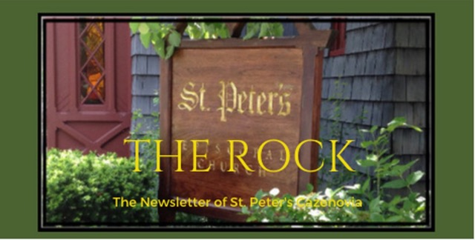

January 2024

Truth, by which the world is held together, has sprung from the earth, in order to be carried in a woman’s arms.
— St. Augustine

St. Peter’s News

A Message from our Rector
Beloved of St. Peter’s,
As I write this, the new year is fast approaching. Perhaps looking ahead to 2024, we are filled with excitement at the possibilities that lie ahead of us. We might also be looking ahead with a sense of unease, as we anticipate a potentially-contentious election year and continued war abroad. Many of us may be holding both of these feelings at once. The new year is an opportunity to recommit. Often, we think of it as a time to pick up physical activities that are good for our bodies, but in times like these, it is important to prioritize spiritual practices, as well. What feeds your soul? What nourishes your connection to God? What reminds you that we are all siblings? Let’s dedicate time for these practices that strengthen those areas of our lives. While we’re at it, let’s give ourselves permission to rest and to take care of our mental health, too. Let’s work together in community to foster hope and to stay in relationship with one another.

In the month ahead, we will gather for our annual parish meeting, and we will resume our study of the Bible and our Episcopal identity. Most importantly, every Sunday, we will gather as the body of Christ to focus on what is really important in our lives — living as children of God and beacons of hope in difficult times. As we look ahead to this next year with whatever emotions come, may we commit to keeping God at the center.

With hope,
Rebecca+

Annual Meeting 2024

We will be holding our Annual Parish Meeting on January 21, 2023 following the 10:00 am service. This is an important event in the life of the church — it is one of the primary places where parishioners learn what is going on in the church, including the state of the church’s finances. It is also an opportunity for folks to participate in the decision-making and leadership selection of the church. According to the Canons of the Episcopal Church, churches are required to meet annually to approve the budget and elect vestry members, including wardens.

We will be electing two vestry members and a warden at this year’s annual meeting. Vestry members who are vacating their roles on vestry are Bob Conway (2021-2024) and John Limmer (2021-2024). Cynthia Maxwell Curtin will be vacating her role as senior warden (2022-2024) but will remain on vestry for one more year. Per our bylaws, McEwan van der Mandele will remain on vestry as warden (2022-2024).

Our slate of nominees, as put forth by the nominating committee (consisting of McEwan van der Mandele, Bob Conway, Marti Cook, and Cyndi Pratt) are: Lorie Riedel (2024-2027) and Rick Lounsbury (2024-2027). Nominee for warden, selected per parish bylaws, is Suzanne Evans (2024-2026).

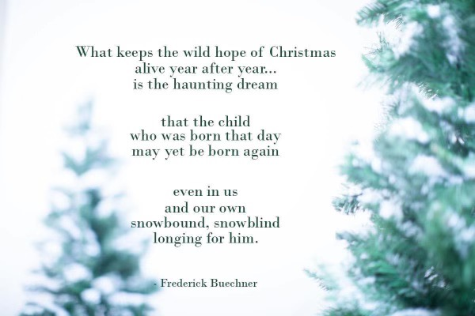

Two Short Church Seasons

After all the preparations of Advent, the excitement of practically the whole month of December, and the beauty and excitement of Christmas Day, it’s interesting that the season of Christmas is our church’s shortest.

According to the Dictionary of the Episcopal Church, “the Christmas season lasts twelve days, from Christmas Day until Jan. 5, the day before the Epiphany.” During these twelve days, there are certain ones that commemorate key events in Jesus’ early life. Childermas marks the day that Herod killed all the infants as he sought to kill Christ. The Feast of the Circumcision or the Holy Name of Our Lord Jesus Christ, celebrates when Mary and Joseph presented Christ in the temple for naming. Christmas ends on Twelfth Night, which marked the night of the coming of the wise men to visit the baby Jesus in Bethlehem.

Around 567 AD, the church set aside the season of Christmas as a sacred festival season. Christmas festivities continued for these twelve days through the Middle Ages and even into the modern era.

On January 6th, the season of Epiphany begins. It lasts between 4 and 8 weeks depending on the Date of Easter. This year Lent begins on, February 14th, Valentine’s Day. So soon already!

Epiphany comes from the Greek epiphaneia, meaning “manifestation” or “appearance.” The Anglican Compass says, “in the context of the Church year, Epiphany refers to the appearance of Jesus Christ as the savior of the world—of Israel and the Gentiles. For this reason, Epiphany is commonly associated with the visitation of the Magi, who were almost certainly Gentiles.”

The Dictionary of the Episcopal Church continues to describe Epiphany as the season when we will hear many Gospel stories that describe the life, teachings, and miracles of Jesus!

Let us savor these two short seasons and enjoy the many Gospel stories telling us about the life, teachings, and miracles of Jesus!

Members of our Congregation

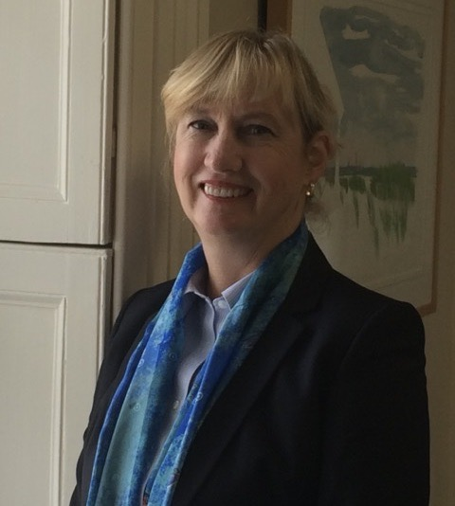

Wrapping up!

Cynthia Maxwell Curtin, Sr. Warden

I am finishing up my second year as senior warden. Under our revised by-laws, I am glad to say, a new senior warden will be taking over after the annual meeting in January 2024. I am not going anywhere, however, but will find new ways to contribute to this wonderful spiritual home.

Thank you for your support as we have walked this journey together. Your support is even more meaningful in that your prayers got me through the recovery from the accident on September 11, 2022.

Please continue to pray for St. Peter’s—how we can serve Christ, be Christ’s light in this community and beyond and continue to support each other in our journey as God’s children.

Much love,

CMC

Ministries and Committees

News from the music gallery

December was the month of Advent and Christmas Celebration. From contemplative to jubilant, music during the month of December fit perfectly with the liturgy, in anticipation and celebration of Jesus’, the Christ child’s, birth. On December 3rd Bach’s “Coffee Cantata“ opened the season of Advent and the closing of our annual pledge season. On December 17th, the choir, joined by our own violinist, Beverly Fernagut, delivered meaningful music in our Advent service of Lessons and Carols.

Following were the Longest Night and Advent IV services, which Meredith Limmer enhanced with beautiful music on organ and flute.

Christmas Eve was indeed a blessed evening from the message to the music to its collective celebration. In our beautifully decorated church our choir served in both the 4 and 7 PM services. The musicians who joined us for the season were friends of St. Peters, acclaimed soprano Janet Brown, Symphoria musicians Edgar Tumajyan, Noemi Miloradovich, Spencer Philips, Jordan Gunn.

We are blessed with our own musicians, Steve, Amy, Beverly and Meredith who provided music throughout Advent and as well as throughout the year. We are looking forward to the Epiphany season, under leadership of our dear rector Rebecca, and the vestry.

With thanks,
Ida

Introducing our Choir—one Member at a Time

St. Peter’s is blessed with many of our own musicians. Choir members practice diligently and sing during the offertory, the service music, and often surprise us during a postlude. We regularly have the pleasure of listening to violin, organ, piano, flute and cello music played by church members. Ida will be highlighting one of these noted musicians every month, starting with Meredith.

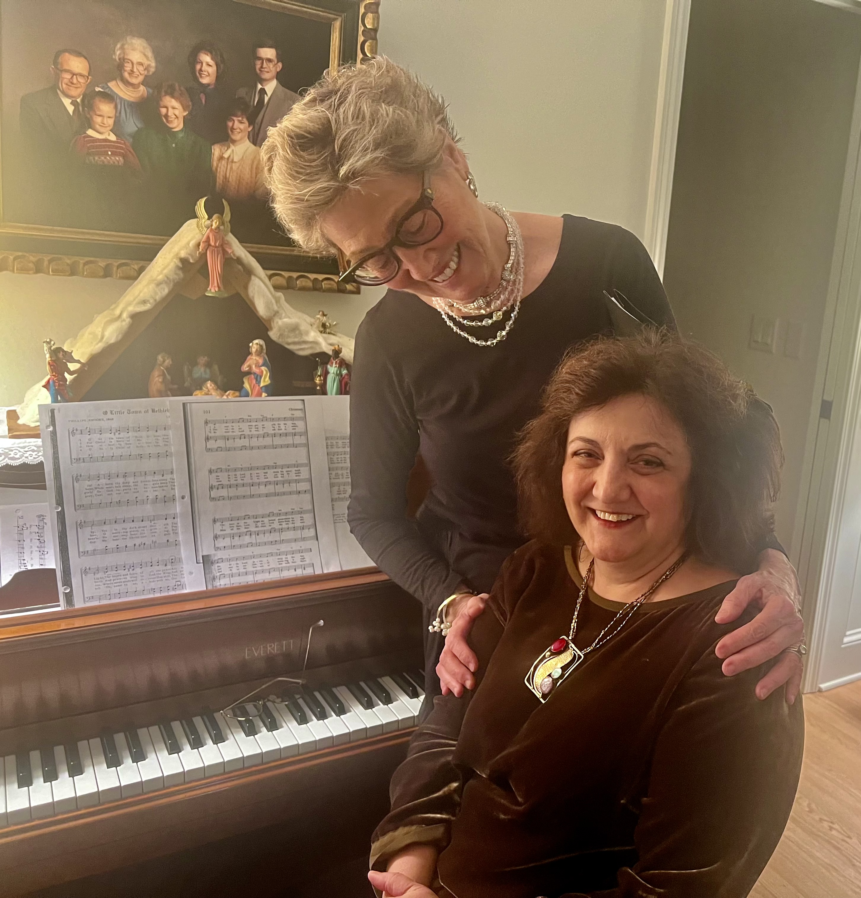

Meredith grew up in a musical household; her dad played alto sax, ukulele, banjo and was on early radio with Ozzie Nelson during the Jazz Band Era. Her mom played her Steinway. Meredith, having played piano from age 6, expanded her studies at The Northfield School in Massachusetts. She graduated, winning the coveted Chopin Piano Prize. At Skidmore College she majored in music ed with professors who had been at Julliard during the Van Cliburn era and received a music history degree from Drew University, graduating summa cum laude with honors in music. Further studies included private lessons with first chair flautist of NJ Symphony and private pipe organ lessons with a graduate of Westminster Choir College. She frequently took week-long immersion studies with conductors, like Robert Page from Carnegie Mellon and Helen Kemp.

Meredith taught piano and flute, privately, for almost 40 years while raising three children. She began receiving frequent freelancing requests at around 18 on organ, piano and flute and was often hired to play for weddings, hundreds of funerals, rehearsal dinners, fancy dinner parties and fundraisers. She subbed in many churches and temples.

Two of her career highlights were playing for more than 8 years in a Roman Catholic Church while the organist had a lung transplant and playing at a pipe organ job, involving a 4 manual Aeolian Skinner with side ranks of special pipes, in St. Peter’s, Morristown, NJ. She also taught one semester at a private school, Newark Academy, where all her children attended and John spent his career of 40 academic years.

After leading a chorus and working at a variety of sub jobs in private schools, she went back to one on one teaching. Her students ranged from age 6 to retired engineers! She often had a waiting list of 10 years. Additional music activities always included church choirs, including Masterwork Chorus which performed about eight full Handel “Messiahs” in venues such as Carnegie Hall and Lincoln Center with a NY Philharmonic orchestra, to sold out audiences. She enjoyed preparing students to compete and win competitions, plus prepare audition recordings for both secondary and college level admissions. Her students went on to Berklee School of Music, Peabody at Johns Hopkins, among other places. As Meredith says, “Music is still a huge part of my life and my psyche.”
Written by Meredith

Greetings from the VESTRY!

We wrapped up the year by having a productive meeting followed by a bit of a festive gathering.

The Finance Committee is busy finalizing the budget. Thank YOU for your pledges and your commitment of time and talent to make it all possible!

We are looking forward to the annual meeting and continuing the good work ahead!

Best,
Cynthia Maxwell Curtin
Sr. Warden

.

News of St. Peter’s and the Greater Community

Caz Cares was a particularly busy place during the time leading up to Christmas. Families came in to get gifts for their children, volunteers – in a stream-lined process – packed dry food as well as fresh produce and meat which another group distributed to the families who picked it all up.

This Christmas, more than 230 (over 800 individuals) were the recipients of these bags of fresh and dried foods. A great big Thank You! to all who donated, volunteered or otherwise helped make this possible, as well as everyone who contributes time, goods, money to support the very worthy Caz Cares cause throughout the year!

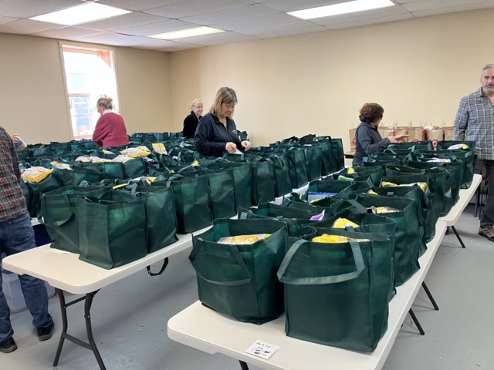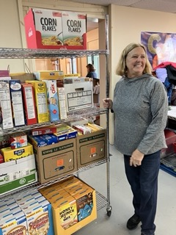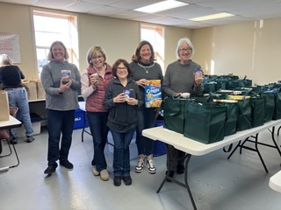

Diocesan News

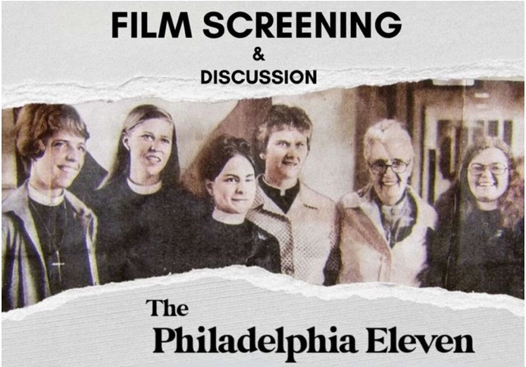

The Philadelphia Eleven Documentary Screening

In 1974, a group of 11 women and their supporters organized their ordination to become Episcopal priests in an act of civil disobedience. This story is told in a compelling new documentary, The Philadelphia Eleven. Come see this documentary with us in Auburn, Watertown or Rome on January 13, at 10am with conversation and Q&A to follow.

Join us at one of the following locations:

Ss. Peter and John Episcopal Church
169 Genesee St,
Auburn, New York 13021

Zion Episcopal Church
140 W Liberty St
Rome, NY 13440-5718

Watertown: Trinity Episcopal Church
227 Sherman St
Watertown, NY 13601-3611

Calendar

Events in January
3 noon Noonday Prayer with Centering Prayer
4 10:00 am Bone Builders (Parish Hall)
6:00 pm Healing Prayer with Communion
7:00 pm Choir Practice
7 10:00 am Sunday Service followed by Coffee Hour (Parish Hal) and
Adult Formation: Walk in Love
8 10:00 am Bone Builders (Parish Hall)
5:00 pm Volunteer Day at the Friendship Inn
8:00 pm AA Meeting (Parish Hall)
10 noon Noonday Prayer with Centering Prayer
11 10:00 am Bone Builders (Parish Hall)
7:00 pm Choir Practice
14 10:00 am Sunday Service followed by Coffee Hour (Parish Hall) and
Adult Formation: Walk in Love
15 10:00 am Bone Builders (Parish Hall)
16 9:00 am Bible Study on Paul and His Writings (classroom by Parish Hall)
17 noon Noonday Prayer with Centering Prayer
18 10:00 am Bone Builders (Parish Hall)
7:00 pm Choir rehearsal
21 10:00 am Sunday Service followed by Coffee Hour (Parish Hall) and
Adult Formation: Waling in Love
22 10:00 am Bone Builders (Parish Hall)
23 9:00 am Bible Study (classroom by Parish Hall)
24 noon Noonday Prayer with Centering Prayer
25 10:00 am Bone Builders (Parish Hall)
7:00 pm Choir Practice
28 10:00 am Sunday Service followed by Coffee Hour (Parish Hall) and
Adult Formation: Practicing Our Faith
29 10:00 am Bone Builders (Parish Hall)
30 10:00 am Bible Study (classroom by Parish Hall)
31 noon Noonday Prayer with Centering Prayer

Ss. Peter and John Episcopal Church
169 Genesee St,
Auburn, New York 13021

Zion Episcopal Church
140 W Liberty St
Rome, NY 13440-5718

Watertown: Trinity Episcopal Church
227 Sherman St
Watertown, NY 13601-3611

__________________________________________________________________________________________

Copyright © 2023 St. Peter’s Episcopal Church, all rights reserved

Our mailing address is:
St. Peter’s Episcopal Church
10 Mill Street
Cazenovia, NY 13035
315-655-9063

Email us at:
parishoffice@stpeterscaz.org
Find us at:
www.stpterscaz.org

