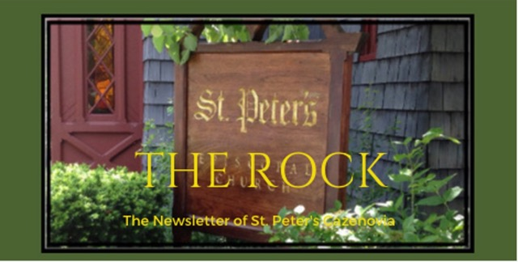

**July 2023**

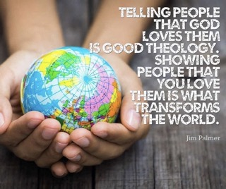

St. Peter’s News

**A Message from our Rector**

Beloved in Christ,

Happy summer! What a green and growing season we are in. On July 12, we will have our Celebration of New Ministry together here at the church, and it feels especially auspicious to formally begin our time in ministry together when God’s abundance and creative power is so fully on display. As Brad and I experience our first summer in Central New York, we are overwhelmed by the beauty and the bounty. This week we went to Mosher Farms and bought the most delicious strawberries! Thanks to a thoughtful surprise from Stan and Robert, we have our own vegetable garden at the rectory, growing tomatoes, peppers, zucchini, carrots, potatoes, and red cabbage — we cannot wait to share the produce of this garden! Every day, Brad and I walk out to tend the garden and to check on its progress. With flowers planted and blooming and animals visiting the back yard, the rectory feels like a little bit of Paradise. In these past few weeks, the presence of God has felt even more palpable — God made manifest in all of the living things. Perhaps because of this, I have been meditating quite a bit on Psalm 104. It is one of my favorite psalms, full of imagery of God’s creative power and the glory of all creation. Here is a portion of the psalm for your enjoyment (NRSVUE) — in the days ahead, may you find God in the glory of the world around you and may you celebrate it. I cannot wait to see what God will grow in our shared ministry here at St. Peter’s!

With love & joy,

Rebecca+

Bless the Lord, O my soul.

O Lord my God, you are very great.

You are clothed with honor and majesty,

wrapped in light as with a garment.

You stretch out the heavens like a tent;

you set the beams of your chambers on the waters;

you make the clouds your chariot;

you ride on the wings of the wind;

you make the winds your messengers,

fire and flame your ministers.

NRSVUE

. . . . You cause the grass to grow for the cattle

and plants for people to cultivate,

to bring forth food from the earth

and wine to gladden the human heart,

oil to make the face shine

and bread to strengthen the human heart.

The trees of the field are watered abundantly,

the cedars of Lebanon that he planted.

In them the birds build their nests;

the stork has its home in the fir trees.

 The high mountains are for the wild goats;

the rocks are a refuge for the coneys.

You have made the moon to mark the seasons;

the sun knows its time for setting.

You make darkness, and it is night,

when all the animals of the forest come creeping out.

The young lions roar for their prey,

seeking their food from God.

When the sun rises, they withdraw

and lie down in their dens.

 People go out to their work

and to their labor until the evening.

O Lord, how manifold are your works!

In wisdom you have made them all;

the earth is full of your creatures.

 There is the sea, great and wide;

creeping things innumerable are there,

living things both small and great.

 There go the ships

and Leviathan that you formed to sport in it.

. . . . I will sing to the Lord as long as I live;

I will sing praise to my God while I have being.

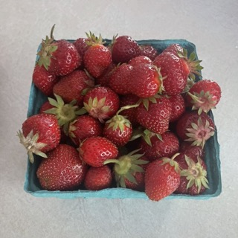  

**Celebration of a New Ministry**

On July 12 St. Peter’s Church will be joined by Bishop Dedee to joyfully celebrate Rev. Rebecca’s new ministry here with us! We will mark this occasion with a special church service and joyous fellowship.

The rite we will be celebrating together is grounded in our baptismal ministry and is described in this way: The catechism of the Book of Common Prayer (1979) indicates that there are four categories of ministers, beginning with the laity. Baptism is seen as the sacrament that initiates Christians and empowers them for ministry. As articulated by one of the pioneers of renewed appreciation of baptismal ministry: “...there is one ministry of the one body, which is Christ’s ministry as exercised through that body. All vocations contribute to the efficacy of that one ministry, expressed in mission. All baptized people – lay and ordained – participate in it according to the gifts given them.” (Stewart C. Zabriskie, Total Ministry. 1995: Alban Institute, page 7) Hence, pastoral leadership and oversight both spring from and need to be celebrated within the community of the baptized.

From a baptismal-ministry frame of reference, the rite entitled “A Celebration of New Ministry” in the Book of Common Prayer focuses almost entirely upon the priest, with little recognition of the ongoing ministry of the congregation. Since the development of that rite, the imbalance has been noted and further attention has been paid by the Church to naming and celebrating the role of all the baptized.

The rite, entitled “The Renewal of Ministry with the Welcoming of a New Rector or Other Pastor,” incarnates mutuality among the ministers of the Church. By setting ordained leadership within the context of baptism, and commending a variety of gifts, this liturgy serves as an alternative to its predecessor, with the caveat that its differences from 1979 are intentional.

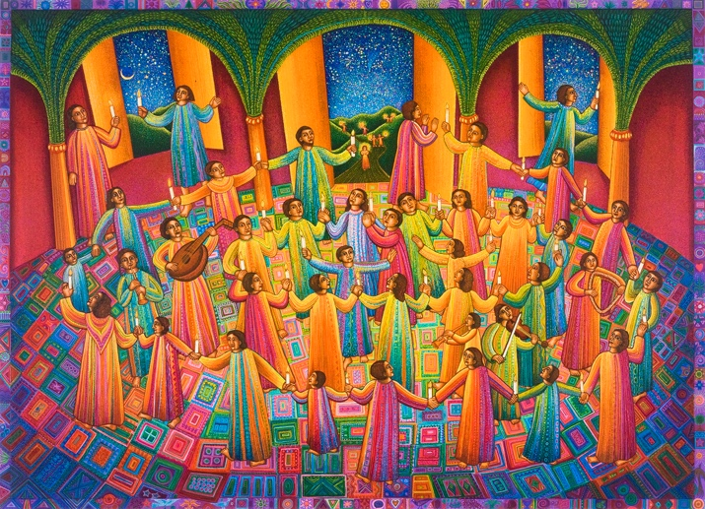

Members of our Congregation

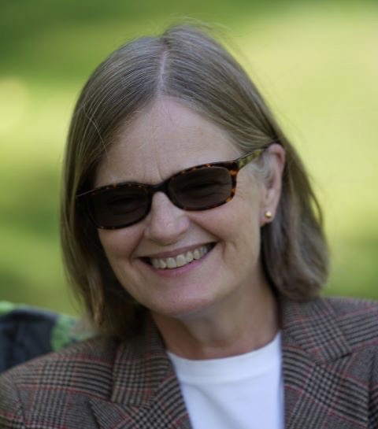

**Beverly**

We all see Beverly when she gifts our Sunday services by playing the violin, and her behind the scenes enthusiasm and skills are always at work for our church, especially now, as she is helping with our budget and financing. Thank you, Beverly!  
  
“Beverly is currently co-Treasurer and a member of the Finance Committee; she has also served as the Vestry Clerk. She has been a member of the Choir and occasionally plays violin during the mass.

Originally from Seattle, Beverly moved to Cazenovia five years ago after a career abroad. For over 20 years, she served first as a music teacher and later as a school superintendent for U.S. Embassy and international schools overseas. She lived and worked in England, France — where she met her husband, Philippe — Germany, Zambia, Cameroon, and India. She is particularly proud of her work with the Indian Ministry of Education to make quality international school education available to all families, poor as well as wealthy; for this she was recognized as one of the five most influential women in India.

Beverly now works as an options trader; in addition, she mentors aspiring international school leaders and tutors English, French, and SAT Prep part-time.” *

*Written by Beverly

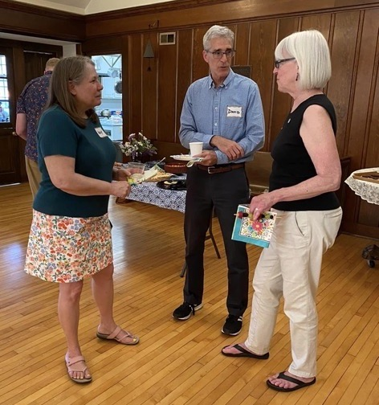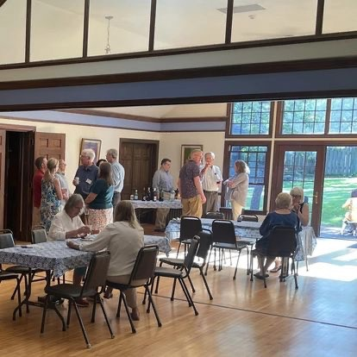

**Newcomers Welcoming Gathering**

One evening in June, members of our Vestry and Hospitality Committee hosted an informal dinner for new members of our congregation in the Parish Hall. The gathering was full of joy and fellowship. Let's all spread that joy! We really are all members of our church’s Hospitality Committee!

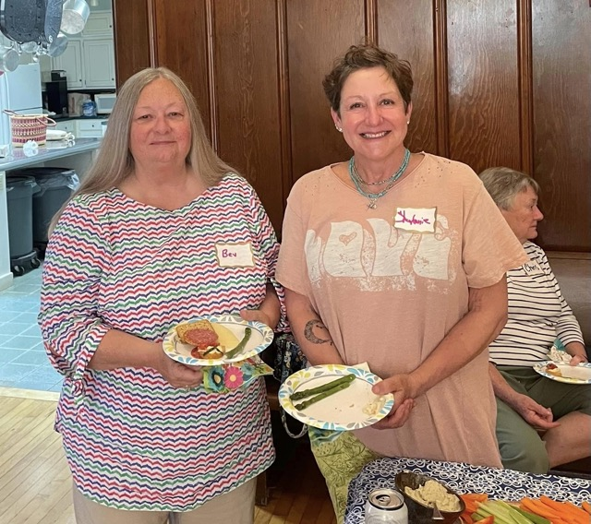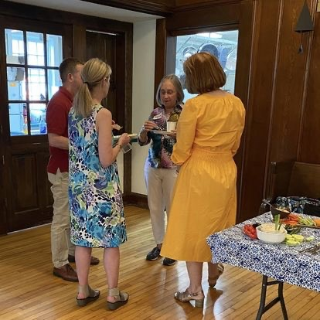

**Summer Bible 101 Book Read**

*Bible Stories for Grown-Ups*, written by Josh Scott, will be the book for our July book read gathering. This book looks at familiar Bible stories and reveals new details and interpretations.

Rev. Rebecca will lead a group discussion of this book on July 26th at 6:00 pm in the Parish Hall.

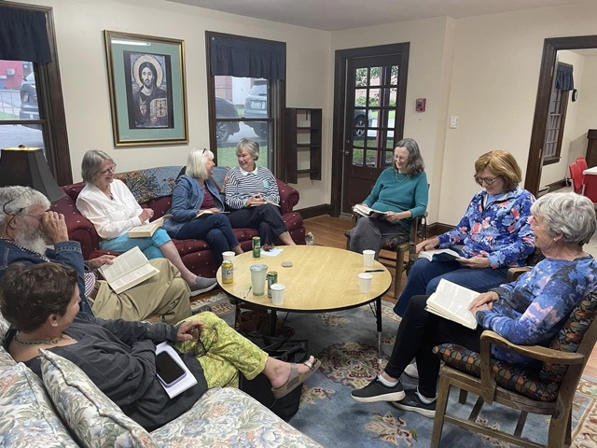 

A lively group of readers participated in our summer Our book for July

book read where they discussed *Reading the Bible*

*Again for the First Time* in one of our newly finished,

small and cozy rooms in the Parish Hall.

Music Ministry

**Choir––the beating Heart of St. Peter's Church**

What I love about choir: pretty much everything! Musically, it reminds me of "first principles" that are touchstones. We sing complicated music, mostly from the western tradition that dates back to the Renaissance in Europe, and much of our music itself developed simultaneously with the concept of human agency, creativity, and, ultimately, the importance of each of us, always an important concept to remember in these unharmonious times. While it's beautiful, the music reminds me about the possibilities of collaboration in harmony (not just musically, of course, but working together without rancor on a variety of non-musical projects). And, finally, singing in the choir emphasizes for me the best of what it is to be an Episcopalian: respecting our roots and tradition, but not too much; working to improve, as we know that, no matter how good we sounded on Sunday, we can always do better; and collaborating, sometimes with different ideas towards a common goal of excellence in service of a power greater than our own.

Written by Steve

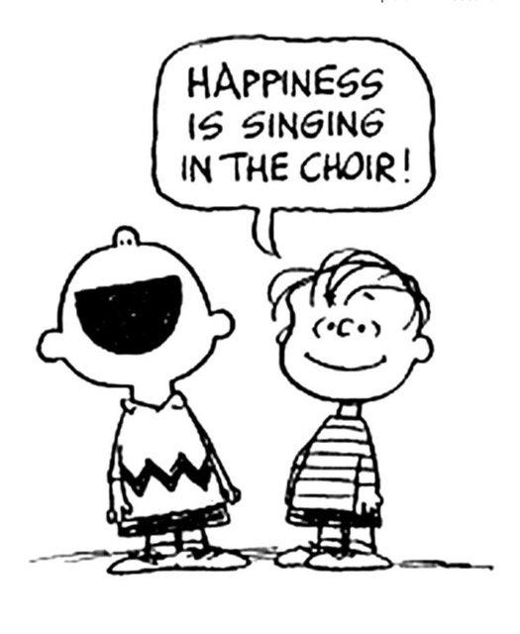

**Notes from the Music Gallery**

St. Peter’s choir is in recess for the summer. However, music in the church goes on with Sunday services, funerals and special events.

On June 24th we celebrated “Mass on the Grass”. It was Rev. Rebecca’s first Mass on the Grass, and it was very well attended. Thank you, Jason for playing the guitar and providing music for the service.

On July 12th at 7 PM, we will celebrate Rebecca's “New Ministry” at St. Peter’s. Many choir members, soloists, and our own instrumentalists will be playing joyful music to celebrate Rev. Rebecca’s new ministry and give voice to our thankfulness for her being here. Music will include Hymns, Anthems, solos, and some of Rebecca’s favorite sacred music.

Looking forward to all the celebrations!

Ida, Music Director

Pastoral Care

**Pastoral Care Committees**

Pastoral care is an ancient model of emotional, social and spiritual support that can be found in all cultures and traditions. The term is considered inclusive of distinctly non-religious forms of support, as well as support for people from religious communities. St. Peter's pastoral care committees and chairpersons are as follows:  
  
PRAYER CIRCLE: Karen OUTREACH: Chris, Louise

EUCHARISTIC VISITORS: TBD RECEPTIONS: Chris, Marti and team

MEALS: Chris, Marti and team

If you are interested in assisting with any of the committees, please contact Rev. Rebecca or Chris.

written by Chris

**Friendship Inn**

The Friendship Inn is located in the Methodist Church and provides a free meal and fellowship for members of our community every Monday. There are no income or age requirements. **It will be closed during July**. Reopening in August, parishioners of St. Peter's will contribute by serving food and chatting with the guests, on the second Monday of each month. Please consider volunteering for this worthy cause. If you are interested, please contact Deb Wilcox, coordinator of volunteers, at [deb@cazmail.com](mailto:deb@cazmail.com) or speak with Rick, a faithful volunteer, from our church.

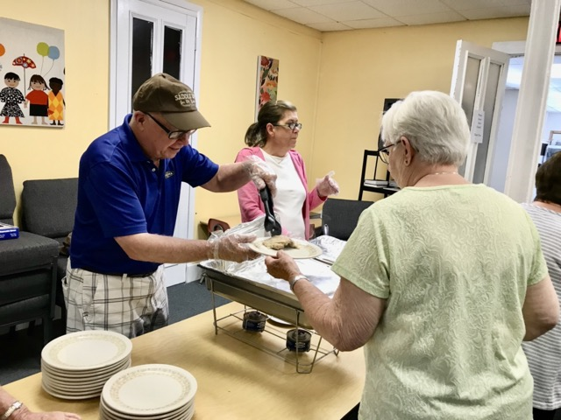

Vestry

**Greetings from the Vestry!**

The Vestry received the results of the audit required by the Diocese, and it pointed out needs for policies and procedures and updating of systems. We are planning to address these issues so that they will not recur in the next required audit.

We also discussed the challenges presented by The Key. It is a drain on time and resources, particularly for Rev. Rebecca and the Vestry. We are having difficulty discerning whether it significantly and positively serves St. Peter’s mission. Despite numerous requests, we do not have enough volunteers to keep it fully staffed.

Cynthia Maxwell Curtin,

Senior Warden

**News of St. Peter’s and the Greater Community**

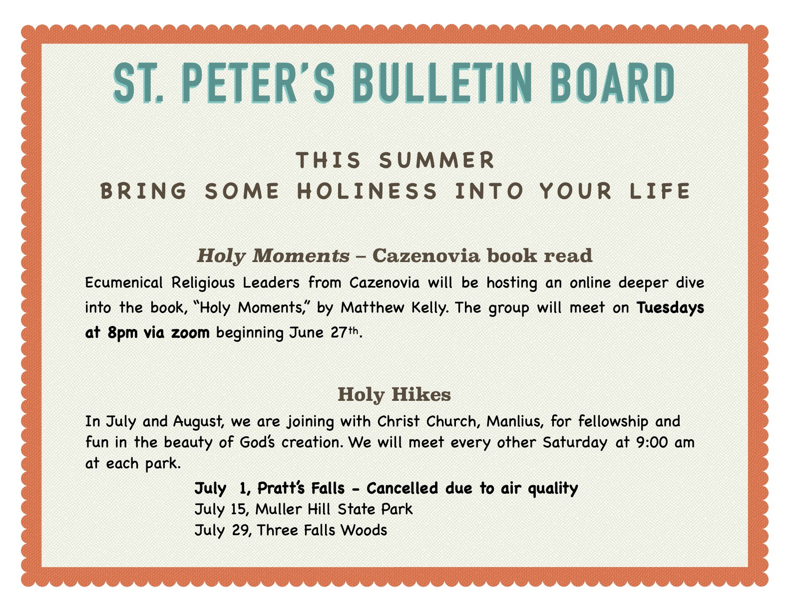



Do you sometimes wish there was a little magic and a few pleasant surprises – you know, like Christmas – in the heat of summer? Well, summertime at the Key means Christmas in July! Look for special “Christmas” sales and events at the Key.                                   

Blue sticker sales take place every day and there is always a special $1 rack to choose from – you will find bargains every day at The Key!  
  
The Key is a ministry of St. Peter’s Church and is staffed by members of our community. Volunteers from our church are still needed. If you would like to volunteer, please contact Dolli or Rev Rebecca.

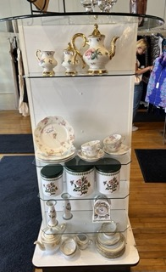



This month, we're collecting **peanut butter and jelly** for CazCares. Please put your donations in the basket in the parish hall. As always, thank you for your generous donations.



The office for Community Resources for Independent Seniors (CRIS) has moved to the Carriage House, a space that allows for more flexibility for CRIS and additional classroom and nursery space for St. Peter’s.

The programs concerning death and dying that CRIS presents with St. Peter's will resume in September.

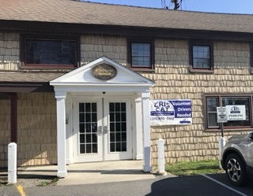 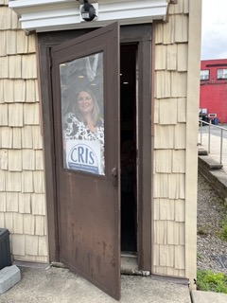

**Diocesan News**

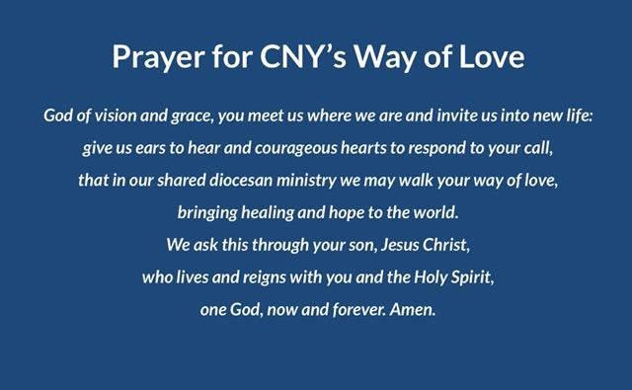

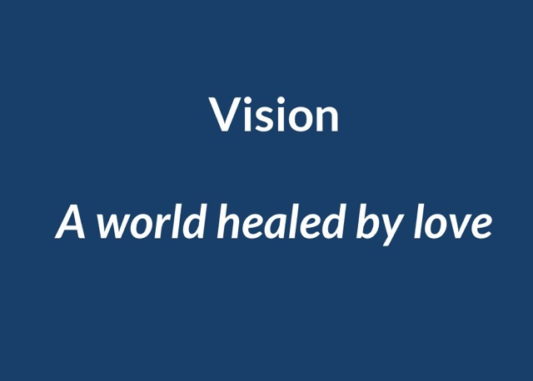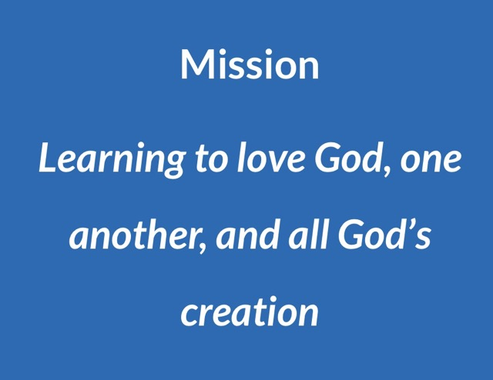

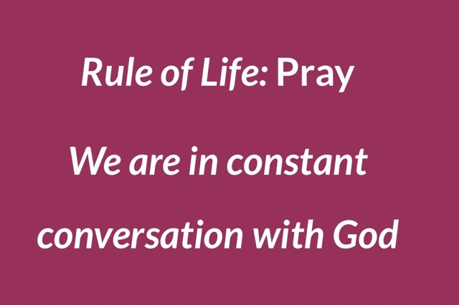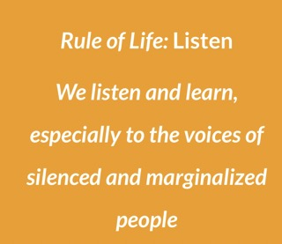

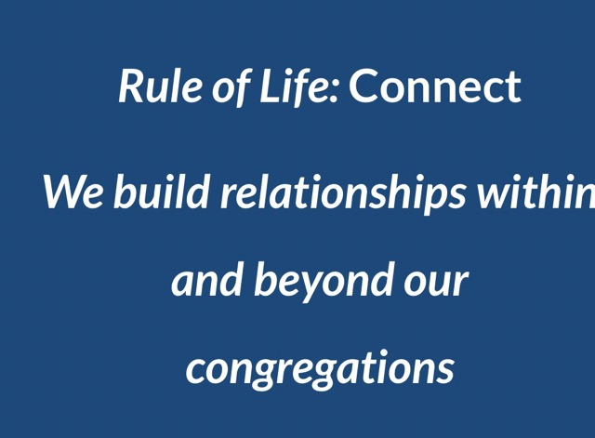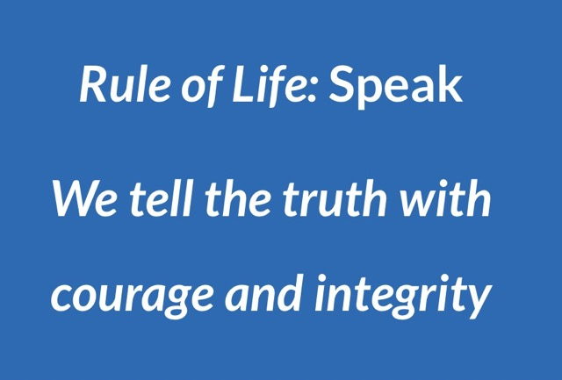

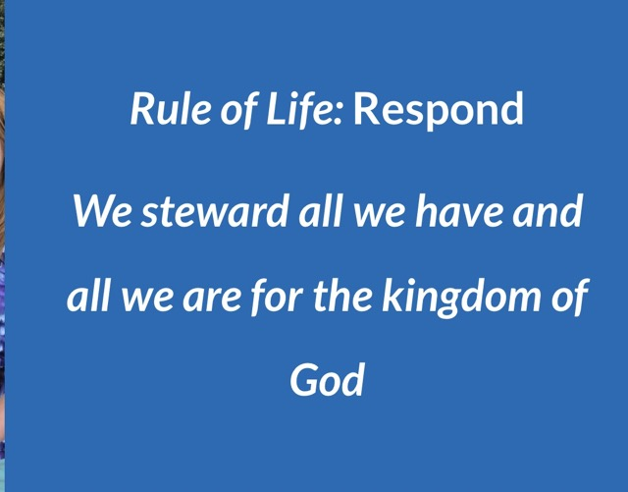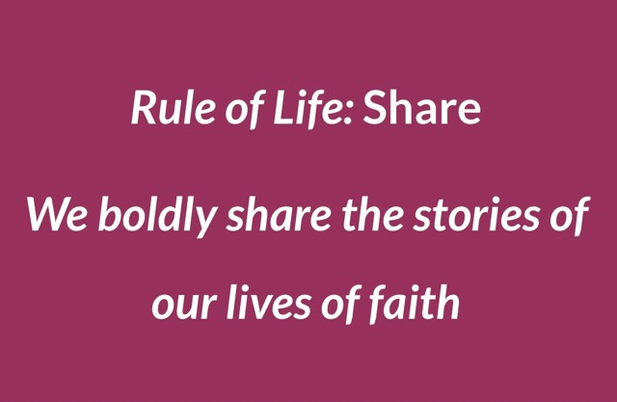

**Calendar**

**Events in July**

1                      **Holy Hike to Pratt's Falls cancelled due to air quality**  
 2     10:00 am   Sunday Service, followed by Coffee Hour (Parish Hall)   
 3     10:00 am   Bone Builders (Parish Hall)  
 4                       **Independence Day, Parish Office closed**  
          8:00 pm   "Holy Moments" discussion on Zoom  
 5     10:00 am   Bone Builders (Parish Hall)  
 9     10:00 am   Sunday Service followed by Coffee Hour (Parish Hall)  
10    10:00 am   Bone Builders(Parish Hall)  
          7:00 pm   AA Meeting (Parish Hall)  
11    11:00 am   Alberding Funeral   
          8:00 pm   "Holy Moments" discussion on Zoom  
**12      7:00 pm**   **Rev. Rebecca's Celebration of New Ministry with Bishop Dedee**  
13    10:00 am   Bone Builders (Parish Hall)  
15      9:00 am   Holy Hike to Miller Hill State Forest  
16    10:00 am   Sunday Service, followed by Coffee Hour (Parish Hall)  
17    10:00 am   Bone Builders (Parish Hall)  
18      8:00 pm   "Holy Moments" discussion on Zoom  
19      7:00 pm   Vestry Meeting (Library)  
20    10:00 am   Bone Builders (Parish Hall)  
22      1:00 pm   Bobsie Evans' Funeral  
23    10:00 am   Sunday Service followed by Coffee Hour (Parish Hall)  
24    10:00 am   Bone Builders (Parish Hall)  
25      8:00 pm   "Holy Moments" discussion on Zoom  
26      6:00 pm   Bible 101 Summer Reading Group (Parish Hall)  
27    10:00 am   Bone Builders (Parish Hall)  
29      9:00 am   Holy Hike to Three Falls Woods

__________________________________________________________________________________________

*Copyright © 2023 St. Peter’s Episcopal Church, all rights reserved*

Our mailing address is:

St. Peter’s Episcopal Church

10 Mill Street

Cazenovia, NY 13035

315-655-9063

Email us at:

[parishoffice@stpeterscaz.org](mailto:parishoffice@stpeterscaz.org)

Find us at:

www.stpterscaz.org