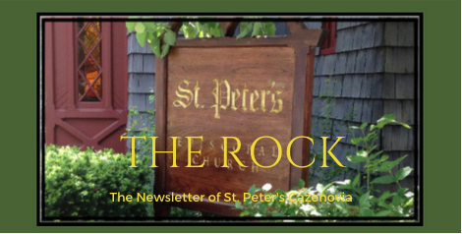

May 2023

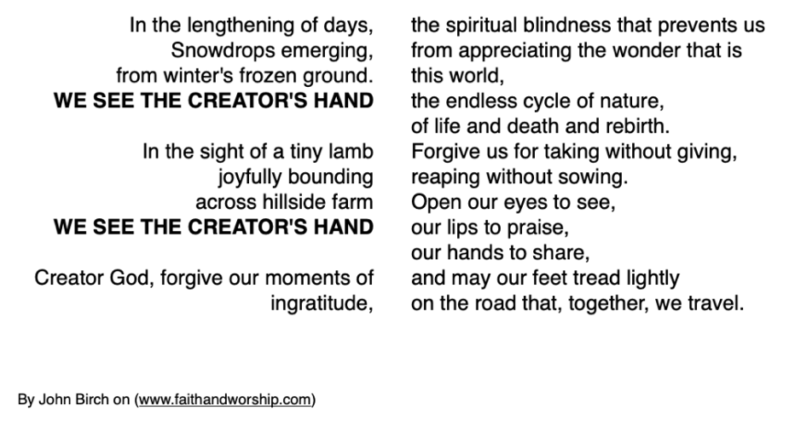

St. Peter’s News

A Message from our Rector

Beloved in Christ,

We end the month of April on the Fourth Sunday in Easter, which is also known as Good Shepherd Sunday because of the imagery from the lectionary readings on this day. So, we head into May pondering what it means to have Jesus as our shepherd. Over the centuries, the image of Christ as the Good Shepherd has become sentimentalized. We forget that in ancient times, and even today in some nomadic cultures, shepherding was a life and death struggle. Shepherds were willing to lay down their life for their sheep, and the sheep were reliant on the shepherds for everything (food, safety, freedom).

The gospel reading from John (John 10:1-10) tells us that it is the shepherd who knows every one of his sheep and calls them by name. In other words, Christ knows us and loves us and longs for us to know that, and to act out of that knowledge. The good shepherd keeps his sheep safe. No matter how frightened or alone we feel, Christ is with us. Christ transcends whatever divisions we, as humans create, and Christ longs to draw us back together.

The language of the sheepfold found in the reading, also reminds us of the comfort of community and the safety we feel with each other. This image in the gospel provides an analogy for the life-giving community we find together as believers. In Jesus’ time, it was not unusual for the shepherd to sleep in front of the opening to the sheepfold in order to keep the sheep safe by night. So we imagine the shepherd becoming the gate, not just to keep danger out, but to keep the sheep together. Christ the gate becomes not only the way into community, but that which unifies the community.

I imagine Christ calling us back together, back into the sheepfold, a community united by our love for him and for one another. So when we are fearful or uncertain, when the wolves and thieves of today’s world, whatever they may be, threaten to scatter us like frightened sheep… I pray that we will turn to our Good Shepherd and follow the sound of his voice, and we will look to his love to show us the way.

Easter blessings,
Rev. Rebecca

Members of our Congregation

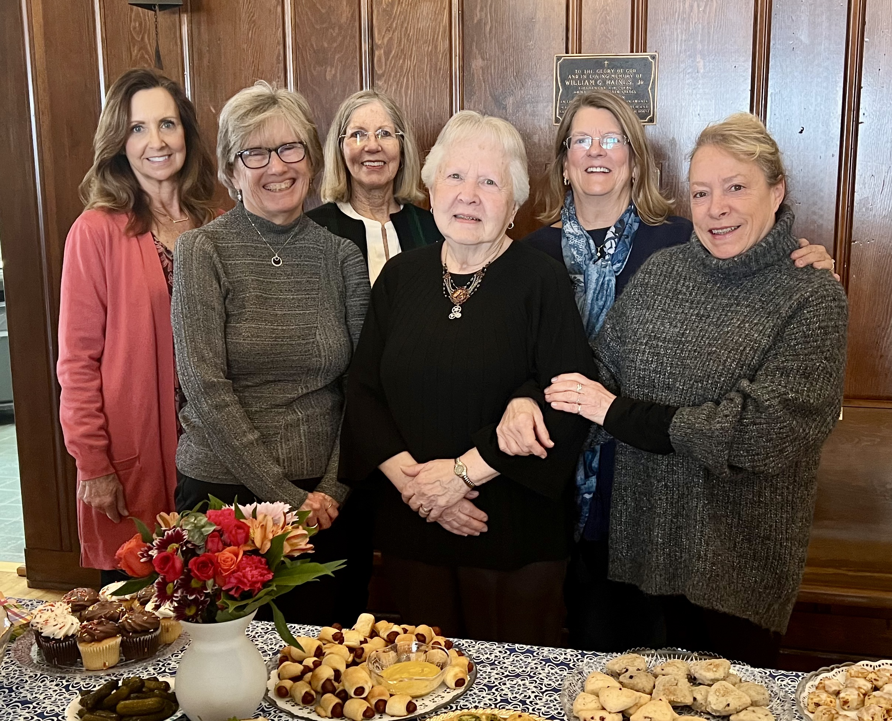

Betty (center) and the Altar Guild at Betty’s retirement party from this ministry.

Everyone knows Betty Putney’s constant and smiling presence up at the altar, in the pews, participating at special liturgies, at The Key, in the parish hall–she is such a positive individual in our church!
In her own words, “I became a member of St. Peter’s in 1952 prior to marriage. Being in love, Ron and I agreed that our family should have one church and worship together, since I was Baptist and he was Catholic. St. Peter’s Episcopal seemed like a great compromise and St. Peter’s was very welcoming. We made many new friends and eventually had two children. I helped teach pre-school/kindergarten and also had a turn at grades 3, 4 and 5 over the years. About forty plus years ago I was invited to join the Altar Guild and it has been such a spiritual journey, which I continued until retirement December 2022. It truly made me feel an integral part of the service. When The Key opened, I volunteered over the years at its various locations, and continue today. Currently I assist with receptions when they are held in the parish hall. St. Peter’s has been my “home” for a long time and I treasure the blessings it has given me.”

Ascension and Pentecost

The Ascension of Christ or Ascension Day falls on Thursday, May 18th this year. On this day, we celebrate that the risen Christ is taken into heaven after appearing to his followers for forty days. The Ascension marks the conclusion of Jesus' post-resurrection appearances. It is the final elevation of his human nature to divine glory and the near presence of God. The Ascension is affirmed by the Nicene and Apostles' Creeds. It is celebrated on Ascension Day, the Thursday that is the fortieth day of the Easter season.

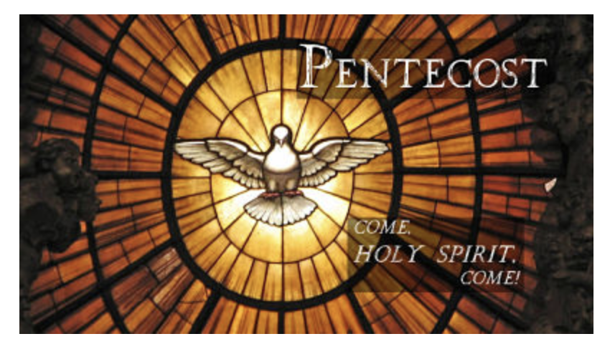

Pentecost falls in May this year, too. It is on Sunday, May 28th. Pentecost means “the fiftieth day.” The term is used in the NT to refer to the coming of the Spirit on the day of Pentecost, shortly after Jesus' death, resurrection, and ascension. Christians came to understand the meaning of Pentecost in terms of the gift of the Spirit. The Pentecost event was the fulfillment of a promise which Jesus gave concerning the return of the Holy Spirit. The speaking in tongues, which was a major effect of having received the Spirit, is interpreted by some to symbolize the church's worldwide preaching. It emphasizes that the church is understood as the body of Christ which is drawn together and given life by the Holy Spirit. Some understand Pentecost to be the origin and sending out of the church into the world. The liturgical color for the feast is red.

From The Dictionary of the Episcopal Church

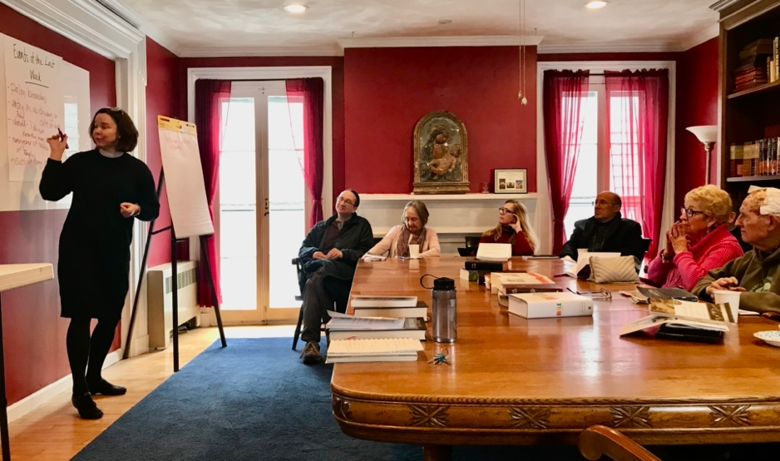

Committee and Ministry News

Coffee Hour –– the 8th Sacrament

Cooking is love made edible! I look forward to preparing coffee hour with Tod and Audrey (when she’s around) because it gives us precious time in the kitchen together cooking for the ones we love at St. Peter’s. Over the past 13 years I can honestly say that some of the most memorable and impactful moments I’ve had at St. Peter’s have centered around food in the Parish Hall! We come together in the Parish Hall after service in a very special way and I’m grateful to be able to help my St. Peter’s family commune over cookies.
Text and recipe by Shannon

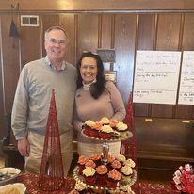

To share the cookie love, here is the Chocolate Chip Shortbread recipe many asked for:
Ingredients

1 cup plus 2 tablespoons salted butter (2¼ sticks), cold (room temperature if you're using a handheld mixer), cut into ½-inch pieces
½ cup granulated sugar
¼ cup light brown sugar
1 teaspoon vanilla extract
2½ cups all-purpose flour
semi-sweet or bittersweet dark chocolate, chopped (not too fine; you want chunks)
Flaky salt

Preparation

Step 1–Line two rimmed baking sheets with parchment paper. Using a stand mixer fitted with the paddle attachment or an electric hand mixer, beat the butter, both sugars and vanilla on medium-high till it’s super light and fluffy (3 to 5 minutes for a stand mixer; 6 to 8 for a hand mixer). Using a spatula, scrape down the sides of the bowl and, with the mixer on low, slowly add the flour, followed by the chocolate chunks, and mix just to blend. If necessary, knead the dough with your hands to make sure the flour is totally incorporated. At this point, the dough should be smooth and feel like Play-Doh with no pockets of flour.

Step 2–Divide the dough in half, placing each half on a large piece of plastic wrap. Fold the plastic over so that it covers the dough to protect your hands from getting all sticky. Using your hands, form the dough into a log shape; rolling it on the counter will help you smooth it out, but don’t worry about getting it totally perfect. (Don't be afraid to make them compact. Shortbread is supposed to be dense. That's part of why it's so good.) You can also do this using parchment paper, if you prefer, but plastic wrap is easier when it comes to shaping the log. Each half should form a 6-inch log, 2 to 2¼ inches in diameter. Chill until totally firm, about 2 hours.

Step 3–Heat the oven to 350 degrees. Brush the outside of the logs with the beaten egg and roll them in the demerara sugar (this is for those really delicious, crisp edges).

Step 4–Using a serrated knife, carefully slice each log into ½-inch-thick rounds (if you hit a chocolate chunk, slowly saw back and forth through the chocolate). If the cookies break or fall apart, just press them back together — the dough is very forgiving. Place them on the prepared baking sheets about 1 inch apart (they won’t spread much). Sprinkle with flaky salt. Bake until the edges are just beginning to brown, 12 to 15 minutes. Let cool slightly before eating them all.

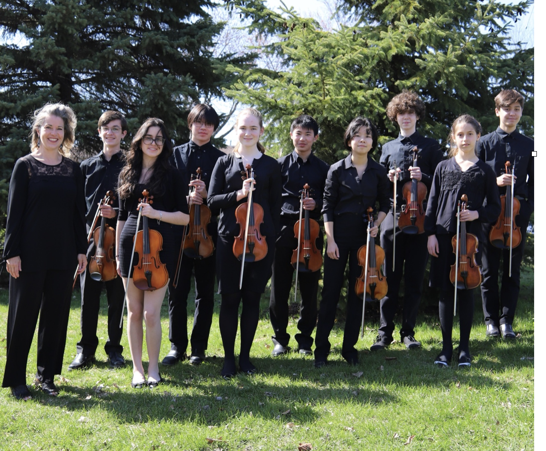

Notes from the Music Gallery

On May 21st, St. Peter’s will host The Mastrangelo Strings, from Suzuki Violin West Ottawa who will provide the music for the Sunday, May 21st, service. We are thrilled to have Sara and her group with us.

Sara Mastrangelo, a former violinist with Syracuse Symphony and dear friend, leads the group in their 2023, Upstate New York Tour. Sara, currently resides in Ottawa, Canada with her husband, violinist Jeremy Mastrangelo, and their children.

Mastrangelo Strings from Suzuki Violin West Ottawa Biography 2023

The Mastrangelo Strings are comprised of the most advanced group of violinists from Suzuki Violin West Ottawa, in Ontario, Canada. Since the group’s inception in 2020, they have performed all over Ottawa. Last year’s highlights include playing as part of the Concerts in Care Series, at the 20th Anniversary concert of the Young String Performers’ Foundation, and at the National Arts Centre.
Since 2015, Coach Sara Mastrangelo has led violin ensembles to China, Argentina, Boston, NYC and across Ontario. She has taught using the Suzuki method for 28 years and founded Suzuki Violin West Ottawa in 2020, after teaching at various places including the McGill Conservatory, St. Peters Arts Academy in Geneva NY, Hamilton College, Hobart and William Smith Colleges, and the Ottawa Suzuki School. She is now on faculty at Carleton University in Ottawa. Mastrangelo also performs regularly with the National Arts Centre Orchestra, Thirteen Strings, Ottawa Symphony Orchestra, and various summer music festivals.

Jennifer Driediger is active as a piano accompanist, performing regularly with two Suzuki Violin schools in Ottawa, as well as at the Ottawa Mennonite Church and the Kiwanis Music Festival. Her daughter, Rachael Driediger, is a member of the Mastrangelo Players.

Violinists: Rachael Driediger, Aleena Long, Percy Miller, Cameron Simpson-Liao, Sofia Torunski, Annie Wang and Sizhan Zhen.

Music for the service

Prelude:
- Vivace from Concerto for Two Violins in D minor, BMV 1043 by J.S. Bach
- Slavonic Dance in E minor, Op. 72 #2 by A. Dvorak, arr. Michael McLean

Offertory:
- Andantino grazioso, Duet in A major (Alla Turca), K.331 by W.A. Mozart

Postlude:

- Salut D'Amour, Op. 12 by Edward Elgar, arr. Norm Abbott

Text and photo by Ida

Welcoming Committee News
A group of us met representing a cross section of parishioners who welcome folks (although, certainly, that responsibility does not lie with anyone group or groups but with all of us.) We came up with over 20 people who have either returned to or started with us since the start of this year! How wonderful is that?

Our welcoming Plan includes:

A Welcoming Hour to be held on Thursday evening at 5:00 p.m. on June 1. Rev. Rebecca will be sending out an Evite with details.

Every Sunday the ushers will be distributing a welcome card to new/returning people. A new colorful hard stock welcoming card will be created.

The ushers will begin ushering people to a pew to sit with folks who have agreed to serve as welcoming hosts. The host will help the new person navigate when to stand, kneel, follow the hymnal and Prayer Book, etc. The hosts will also introduce themselves and invite the new person to coffee hour. If you would like to be a host, please let Cynthia or Rev. Rebecca know.

Finally, this fall, Rev. Rebecca will teach a course regarding the Episcopal church and liturgy not just for new folks but all of us who want to learn.

If you would like to join this new exciting welcoming committee, please talk with Cynthia or Marti.

From notes submitted by Cynthia

News of St. Peter’s and the Greater Community

Spring has sprung at The Key with the acquisition of delicately decorated china, stylish seasonal footwear and activewear for women.

The Brewster Inn is redecorating their rooms and has just made a special donation of home goods to The Key.

And, really, the best bargain of all may be the plethora of small appliances.

The Key continues to be a vibrant and effective ministry in our community.

The Extending the Table Dinner, a delicious fundraiser that supports the resettlement of refugee families in Cazenovia, will be held at St Peters Church on Saturday May 6th. Tickets needed to be purchased by April 30th.

Chef Ngoc Huynh, a Vietnamese refugee who lives in Syracuse, is preparing a delicious menu:
Lemon grass chicken curry with glass noodle salad and spring rolls–it is sure to be a delicious meal!

The food items that we are collecting for Caz Cares in May are peanut butter and jelly. We are also still collecting diapers sizes 4, 5 and 6.
Please put your items for Caz Cares in the basket in the Parish Hall.
As always, thank you for your generous donations!

The CRIS staff has been excited and busy moving into their new offices in the Carriage House. It is starting to look so good. They hope to finish their move by the beginning of the month.
In the meantime, CRIS continues to partner with St. Peter's and others in presenting well attended Conversations about Death and Dying at the Cazenovia Public Library. The next conversation will be at the library on Monday, May 20, on Death at Home.

Diocesan News

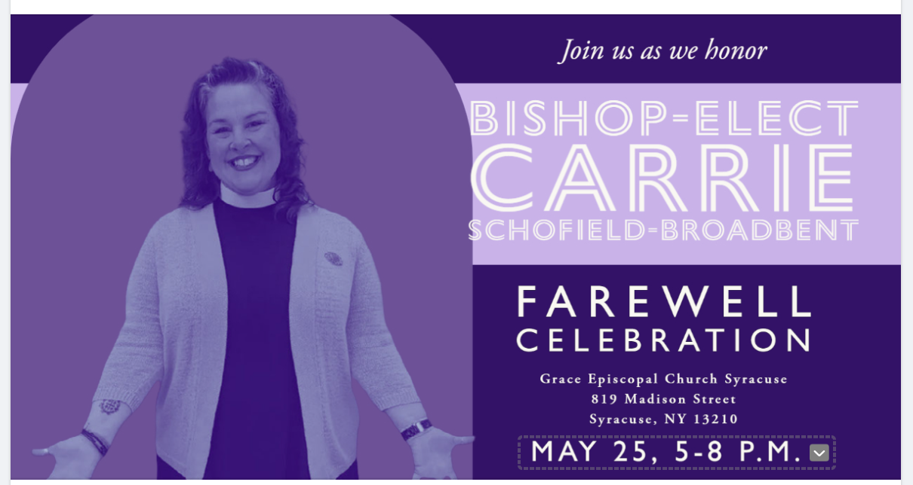

The Rev. Canon Carrie Schofield-Broadbent, who has visited St. Peter’s Church several times, giving us pertinent and joyful sermons and leading us into our new rector search process. We appreciate both of these actions! We congratulate her on her recent election as Bishop Coadjutor of The Diocese of Maryland. We wish her the best of times in her new calling.

Calendar

Events in May

- 10:00 am Bone Builders (Parish Hall)
4 10:00 am Bone Builders (Parish Hall)
7:00 pm Choir Practice
7 10:00 am Sunday Service, followed by Coffee Hour (Parish Hall)
8 10:00 am Bone Buildres (Parish Hall)
5:15 pm Volunteer Day at the Friendship Inn
7:00 pm AA Meeting (Parish Hall)
10 7:00 pm Vestry Meeting
11 10:00 am Bone Builders (Parish Hall)
7:00 pm Choir Practice
14 10:00 am Mother’s Day, Sunday Service, followed by Coffee Hour
15 10:00 am Bone Builders (Parish Hall)
18 Ascension Day
10:00 am Bone Builders (Parish Hall)
7:00 pm Choir Practice
21 10:00 am Sunday Service with the Mastrangelo Strings, Coffee Hour
22 10:00 am Bone Builders (Parish Hall)
25 10:00 am Bone Builders (Parish Hall)
7:00 pm Choir Practice
5-8 pm Bishop-Elect Carrie Schofield-Broadbent’s Farewell
Celebration (Grace Church, Syracuse)
28 10:00 am Pentecost Service, WEAR RED, followed by Coffee Hour
29 Memorial Day, Parish Office closed

__________________________________________________________________________________________

Copyright © 2023 St. Peter’s Episcopal Church, all rights reserved

Our mailing address is:
St. Peter’s Episcopal Church
10 Mill Street
Cazenovia, NY 13035
315-655-9063

Email us at:
parishoffice@stpeterscaz.org
Find us at:
www.stpterscaz.org

