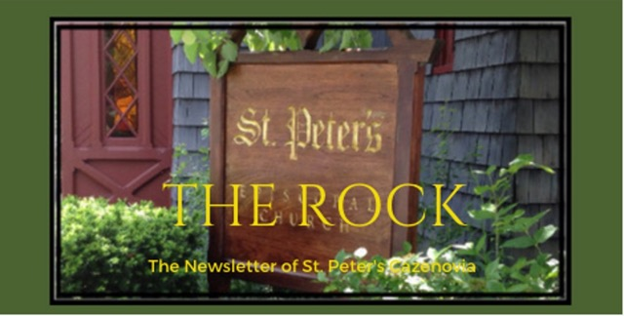

September 2023

St. Peter’s News

A Message from our Rector

Dear Beloved of St. Peter’s,

Fall is in the air & we are looking ahead to new beginnings! It’s time for back-to-school and all of the emotion and energy surrounding this time. Even if we have never sent children of our own off to school, it is likely that we remember the anticipation as the first day of school drew near. Our minds were full of questions: Would our teacher be nice? Would we have friends in our class? Did we have all of our supplies? Could we get more crayons? (Oh wait, that was probably just me.)

Here at St. Peter’s, we are feeling that same sense of anticipation as we look forward to the beginning of a new programming year. We are beginning new classes and adding new services. We have workshops and small groups planned throughout the year, too. In the spirit of the school year, we are approaching all of these offerings as experiments — we’ll try them out for a while & see what works. If there’s not much interest or attendance, we will go back to the drawing board. Regardless, my hope is that you will find something that nourishes your faith in these gatherings. It is also my hope that you and your children or grandchildren will bring your bag, briefcase, or backpack to church on September 10 to be blessed during the service.
To make room for all that we have planned, we have spruced up the rooms next to Fellows Hall, where the CRIS offices were located — we have added a nursery, a classroom, and a small-group meeting room. Please take a peek when you have a chance.

Blessings,
Rebecca

Our Fall Schedule (Begins September 10):
Sundays After Service — Adult Formation: Practicing Our Faith (Walk in Love by Scott Gunn & Melody Wilson Shone)
Tuesdays @ 9:00 am — Bible Study — we’ll begin with the Gospel of Mark & the class gets to choose the book we use as our study guide
Wednesdays @ noon — Noonday Prayer with Centering Prayer
Thursdays @ 6:00 pm — Eucharist with Prayers for Healing (FIRST THURSDAY OF EACH MONTH — begins OCT 5)

A Prayer for the New School Year
God of all wisdom, we praise you for gifting us with curiosity and learning. Give to all students, teachers, and caregivers a clear sense of your love. May they feel your presence throughout this school year. Guide their choices, their quest for knowledge, and their relationships. Use their successes and failures as opportunities to grow in understanding of who you would have them to be. Continue to shape them, that they may walk in the way of Christ, grow strong in Spirit’s love for all people, and know the complete joy of life in you. In the name of Christ our Great Teacher, we pray. Amen.
Linda Witte Henke, adapted, “From the Vine,” in Marking Time: Christian Rituals for All Our Days, Moorehouse Publishing 2001, p. 63

Centering Prayer

Listen in Silence
because if your heart is full of other things,
it cannot hear the voice of God.
Mother Theresa

The Episcopal dictionary defines centering prayer this way: “A method of quiet meditation in which a single symbolic word is used as a sign of one’s willingness to wait on God and be available to God’s presence. This word is used as a point of focus. The discipline involves setting aside twenty minutes or so for quiet prayer. This method has been widely taught and practiced in the Episcopal Church since the early 1980s.”

Now, in September, the time when our lives begin again after our summer vacations, is a perfect time to begin a practice to develop a deeper relationship with God. And though centering prayer may sound like a lot of doing, it really just means making a quiet place inside ourselves so we can rest in God’s presence. Centering prayer is a method of prayer that can help us listen to the language of God, which is silence.

Guidelines for Centering Prayer:
- Choose a sacred word as a symbol of your intention to consent to God’s presence and action. Your word could be “Jesus,’’ “grace,” “love,” etc.
- Sit comfortably with eyes closed to let go of the world around you and make yourself available to God. Gently introduce your sacred word and let yourself simply be.
- When you become aware of your thoughts wandering, gently return to your chosen word.
- After 10 or 15 minutes, begin to withdraw from this stillness. Take a few minutes to thank God for the time spent in prayer and let your mind, spirit and body re-acclimate to your surroundings.

Centering prayer is best done twice a day, for about 20 minutes each time, usually in the morning and afternoon. The centering effects of this type of praying happen during our daily lives.
Theologian Henry Nouwen has said, “the heart is the place of prayer. It is the place where God dwells—the place of the divine—within each of us.” Centering prayer can lead us beyond conversation, to communion with God.

Beginning this month on Wednesdays at noon, St. Peter’s will offer the service of Noonday Prayer with Centering Prayer. Practicing Centering Prayer once a week in church is one good way to learn how to deepen our relationship with God. If you have questions, please speak with Rev. Rebecca.

Members of our Congregation

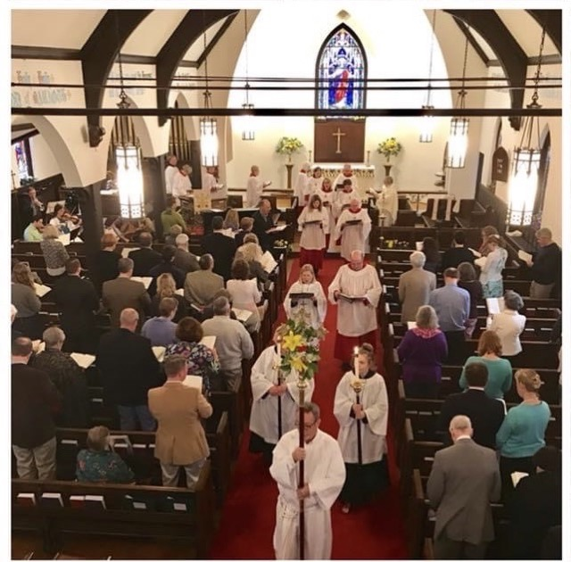

Newcomers

New people have been coming to our church! Some are new to our community, some have decided to try church again, some felt a desire for spiritual growth. What an impact they are making. They are joining our congregation, participating in book groups, preparing food for celebrations, and are just wonderfully expanding our church family. Coming to St. Peter’s Church is “changing their lives” Their coming to St. Peter’s is changing all our lives as well.

Thank you so much, Newcomers!
One of our committees is the Welcoming Committee, and Rev. Rebecca has a gift for reaching out. But really, it is up to all of us to welcome and help to make our church feel like home to new people. A warm greeting, learning names (name tags do help), introductions, conversations, an invitation to coffee hour and upcoming church events, and follow up phone calls all are so important. We need to show new people our welcoming heart.

Ministries and Committees

Committees
Committees at St. Peter’s are where small groups of parishioners combine ideas, work together and form ministries. There is important work to be done in each of them, and new members and/or new ideas are welcome. Our committees and their chairperson are:
Finance – McEwan
Worship – Rev. Rebecca
Hospitality (includes, ushers, coffee hour, welcoming) – Cynthia
Pastoral Care – Chris
Eucharistic Ministers – Don
Altar Guild – Deede
Communications – Rev Rebecca
Prayer Circle – Karen
Buildings and Grounds – Betsy
Music – Ida

St. Peter’s is a pastoral sized church. This means that we have specific leaders but also that our ministries rely on ideas and leadership from all our members. Good communication among leaders and parishioners is important. There is always plenty of work to be done. Ideas are always welcome and needed! If you would like to join one of the committees or have an idea for a new project, a good place to start is by talking with the chairperson of the pertinent committee. Ideas then will be shared among committee members, and if needed the Vestry and Rev. Rebecca. Decisions that require changes to our church properties or that require funding are discussed thoroughly and are decided based on consensus of the committee, the vestry, and Rev. Rebecca.

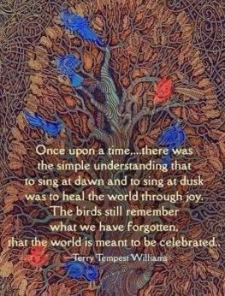

News from the music gallery
St. Peter’s choir is very excited to start the 2023-2024 church season off with a potluck dinner and rehearsal at Judy’s residence.
Choir meets every Thursday at 7pm for rehearsals and at 9:30 am on Sunday mornings for services.
We are looking to expand the choir membership. Anyone who is interested in joining us and be part of our awesome group can email or call any member of the choir or the music director, Ida Tili-Trebicka: Her email address is: ttrebick@syr.edu

Membership is open to anyone; no audition is required.
We have an exciting year ahead, with choral and instrumental music.
Sunday, September 3rd, will be the last “Mass on the Grass” service, followed by the full service with music and choir, on September 10th.
The first date one of St. Peter’s Concert Series will be Sunday October 15th, and is titled Sonatas and Trios. Musicians will be:
Yuri Mitsuhashi (violin), William Ford-Smith (viola) and Ida Tili-Trebicka (piano). The string players are members of Symphoria, Syracuse.

Our theme for the month of September is “Sing to The Lord a New Song!”

Blessing to all,
Ida

News of St. Peter’s and the Greater Community

September is Back to School month at The Key. There are already racks of school clothing in the store and soon consignors and donators will be bringing in warm clothing for fall and winter. Blue ticket items and $1.00 racks continue to offer great bargains.

Caz Cares gives a big THANK YOU to St. Peter’s Church for all its donations of school supplies that made the just completed Back to School event successful!
Our food item for donation during September is tuna fish. Two cans of tuna are given each month to each participating family. Please put your food item in the Caz Cares basket in the Parish Hall.

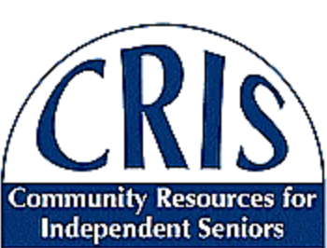

The series presentations offered by CRIS and St. Peter’s Church, “Let’s Talk About Death and Dying,” will resume in September. On Monday, September 25, at 10:00 am, Paul Curtin, lawyer, and Nancy Aureli, RN, will lead a conversation about end-of-life paperwork.
This series will continue in October.

Calendar

Events in September
3 10:00 am Last Mass on the Grass followed by Coffee Hour
4 Labor Day, Parish Office will be closed
7 10:00 am Bone Builders (Parish Hall)
7:00 pm Choir Practice resumes combines with a potluck
10 10:00 am Sunday Service followed by Coffee Hour (Parish Hall) and
Adult Formation: Practicing Our Faith
11 10:00 am Bone Builders (Parish Hall)
5:00 pm Volunteer Day at the Friendship Inn
8:00 pm AA Meeting (Parish Hall)
12 9:00 am Bible Study (classroom by Parish Hall)
13 noon Noonday Prayer with Centering Prayer
14 10:00 am Bone Builders (Parish Hall)
17 10:00 am Sunday Service followed by Coffee Hour (Parish Hall) and
Adult Formation: Practicing Our Faith
18 10:00 am Bone Builders (Parish Hall)
19 9 :00 am Bible Study (classroom by Parish Hall)
20 noon Noonday Prayer with Centering Prayer
21 10:00 am Bone Builders (Parish Hall)
7:00 pm Choir rehearsal
24 10:00 am Sunday Service followed by Coffee Hour (Parish Hall) and
Adult Formation: Practicing Our Faith
25 10:00 am Bone Builders (Parish Hall)
CRIS series on Death and Dying at the Cazenovia Public Library
26 9:00 am Bible Study (classroom by Parish Hall)
27 noon Noonday Prayer with Centering Prayer
28 10:00 am Bone Builders (Parish Hall)
7:00 pm Choir rehearsal

__________________________________________________________________________________________

Copyright © 2023 St. Peter’s Episcopal Church, all rights reserved

Our mailing address is:
St. Peter’s Episcopal Church
10 Mill Street
Cazenovia, NY 13035
315-655-9063

Email us at:
parishoffice@stpeterscaz.org
Find us at:
www.stpterscaz.org

