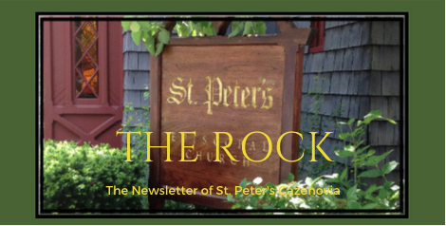

March 2023

St. Peter’s News

A Message from our Rector

Beloved in Christ,
It is now March, and we have stepped fully into the journey of Lent. We begin, this season each year, in the dust of Ash Wednesday, looking inward at our lives, our need for repentance, and our utter dependence on God’s grace. Yet we do not stay here. We move, with Jesus, into stories of healing, of revelation, of life born out of death. We are intentional in how we travel. We silence our Alleluias for a season so that they may ring out more clearly in Eastertide. We follow a more simple pattern of worship, with time for contemplation, rededication, a turning again of our hearts toward God. And we do this in the context of community, of journeying together with Jesus, the disciples, and the community of St. Peter’s, so that we have strength and courage for the journey.

The Ash Wednesday liturgy invites us to observe a holy Lent, the priest saying: I invite you, therefore, in the name of the Church, to the observance of a holy Lent, by self-examination and repentance; by prayer, fasting, and self-denial; and by reading and meditating on God's holy Word. How ever we do this, however we will mark these 40 days (and 6 Sundays), the invitation is before us to step onto the holy road, out into the wilderness, into the unknown, trusting that Jesus will remain with us and that we will remain with Jesus. Perhaps you will find a new way to nurture your faith. Transformation happens in these unknown and holy places, miracles come in the midst of pain, joy comes in the midst of sorrow, life comes forth from death.
Welcome to the journey,
Rev. Rebecca

The Scary Coffee Pot

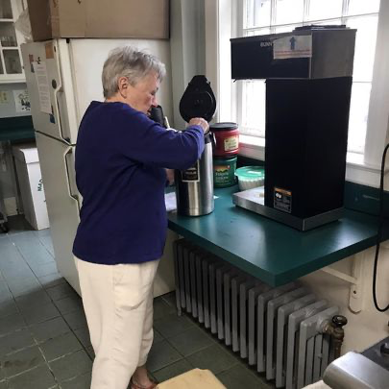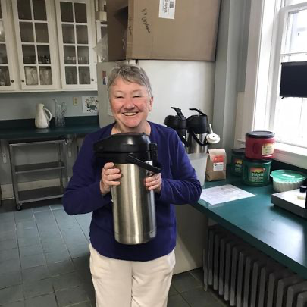

Coffee hour in the Episcopal Church is said to be the 8th Sacrament for good reason! We gather together for food and conversation. This is liturgy* for sure! We are in need of coffee hosts.

Louise will be available at 9:00 every Sunday to make coffee or instruct you in the use of the coffeepot. It’s really not so bad. And let’s keep it simple. You need to bring a treat -store bought treats are great- so are home made. Please supply a carton of half and half. Paper cups, plates, napkins, and stirrers, table cloths, platters, and serving utensils are stocked in the kitchen. Stan sets out the tables and chairs before church. There are always helpers available for clean-up.

If you would like to volunteer as a coffee host, please, sign up on the form on the round table in the parish hall or talk with Sherry or Louise.

From The Oxford Dictionary of the Christian Church

Lent

A Prayer
“During this Lenten season, may we not simply draw away from distraction, but also press further into the gifts of resting, re-centering, and recharging”
From Soujourners

Why is Lent called “Lent”?
In Greek and Latin, the names for Lent make sense, because they’re based on the number 40. The first mention of a period of 40 days, probably of Lent, occurs in the Canons of Nicaea (AD 325; can. 5). The custom may have originated in the prescribed fast of candidates for baptism, and the number 40 was evidently suggested by the 40 days’ fasts of Moses, Elijah, and especially Jesus Himself.
In English it is more confusing. “Lent” comes from the English noun “Lenten,” meaning either “the season of spring” or the period of fasting we now refer to as Lent. "Lenten” comes from the Old English “lencten,” meaning “the season of spring” or “Lent, the period of fasting.” “Lencten” comes from the West Germanic “langitinaz,” meaning “long-days,” or “lengthening of the day'". So, “Lent” refers to the lengthening of the days during springtime.*
*Online Etymology Dictionary

ST. PETER’S BULLETIN BOARD

Weekly formation gatherings during Lent

Sunday Book/Bible Study-

“Entering the Passion of Jesus”- Amy-Jill Levine

Following coffee hour in the library, beginning February 26

Wednesday Simple soup supper and book discussion

“People of the Way”- Dwight Zscheile

Wednesday evenings at 6:00 in the Parish Hall, beginning March 1

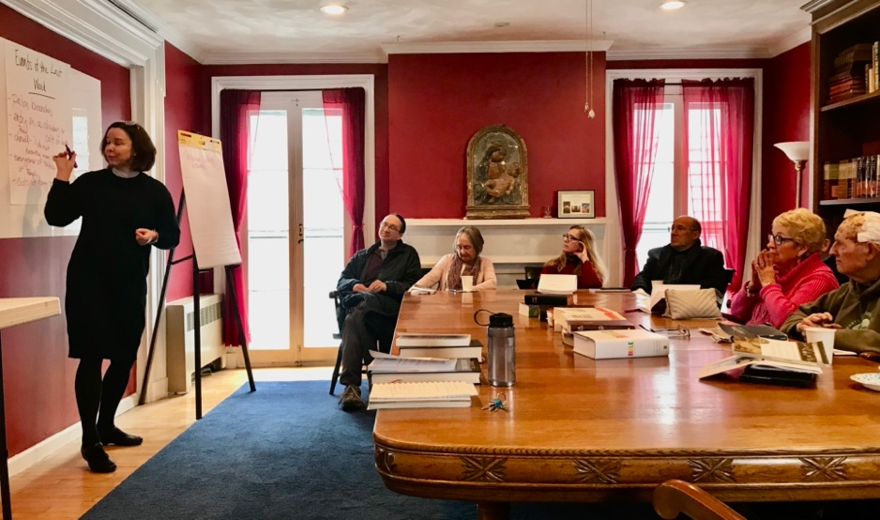

The first of our weekly Bible studies during Lent

Members of our Congregation

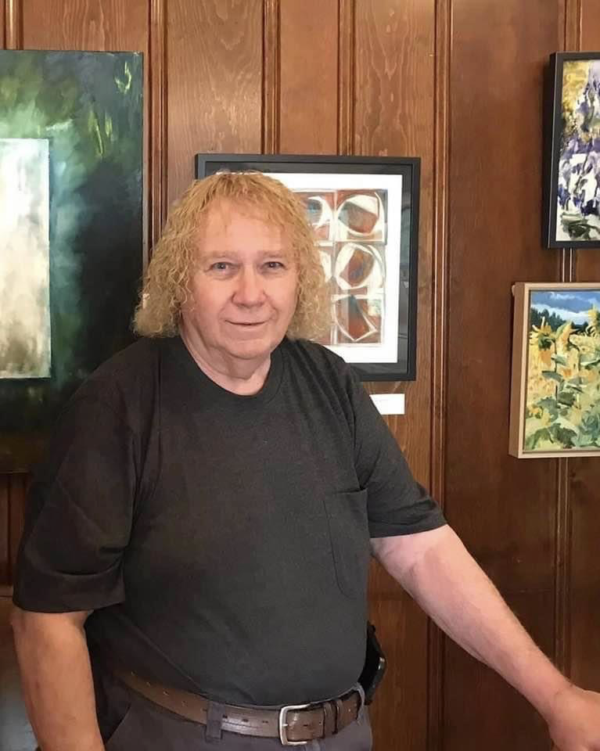

Don Smith
I have been a member of St. Peter's Church since 1977. Since then, I have served on the vestry several times, been both a Jr. and Sr. warden more than once. When on the buildings and grounds committee, I was one of the members that determined the need for the tie rods in the Nave to keep it from spreading. I have also been active as an Acolyte, Acolyte trainer, as well as a lector. Loving the rituals and traditions of the church, I have been a Eucharistic Minister and am currently scheduling and providing training for them. Years ago, I trained as a Licensed Lay Worship Leader, and since then have led Morning Prayer many times.
In 2017, it became apparent that we needed to upgrade the sound system. As I have an electronics background as well as some experience in audio, I took on the task of coming up with a new system. With vestry approval, I purchased the equipment and built our current system.
When Covid hit and it became necessary to put our services on Zoom, I ended up as the lead person for doing so. We started very small with just one basic camera and have grown to our current 4 cameras and several microphones to capture the full service for our members on Zoom.
Now that our church is developing under the leadership of Rev. Rebecca, we are in need of more acolytes and Eucharistic Lay Ministers. As Zoom services and their recordings are here to stay, we also need people to help with recording and photography. Please see me if you are interested in learning more about these ministries.
I am very blessed to be able to serve our Lord and St. Peter's in whatever way my talents allow. St. Peter's is my family, and I love doing what I can to help us grow and thrive.

Music Ministry

Report from the Music Gallery
Music at St. Peter’s is always vivacious and special. It takes our breath away, stirs our souls, and gives us peace. Music in March will prove to be extra special! on March 19th, we will get to enjoy a Lenten liturgical dance, to the music of John Rutter and choreographed by Suzanne Evans, during our Sunday church service. Our concert series that same day, will present Augustine Sobeng, playing our wonderful old pipe organ. While attending SU to work on his Master's degree in Organ Performance, Ida was his graduate advisor. This is Augustine’s second concert at our church. A few years ago, he played for us and was so warmly welcomed that he came to a parish dinner with us all. He is currently pursuing his Doctoral program in Organ Performance and Literature, in the studio of Nathan Laube, at the Eastman School of Music, Rochester University. Please join us for this concert on Sunday, March 19th at 3:00 pm.

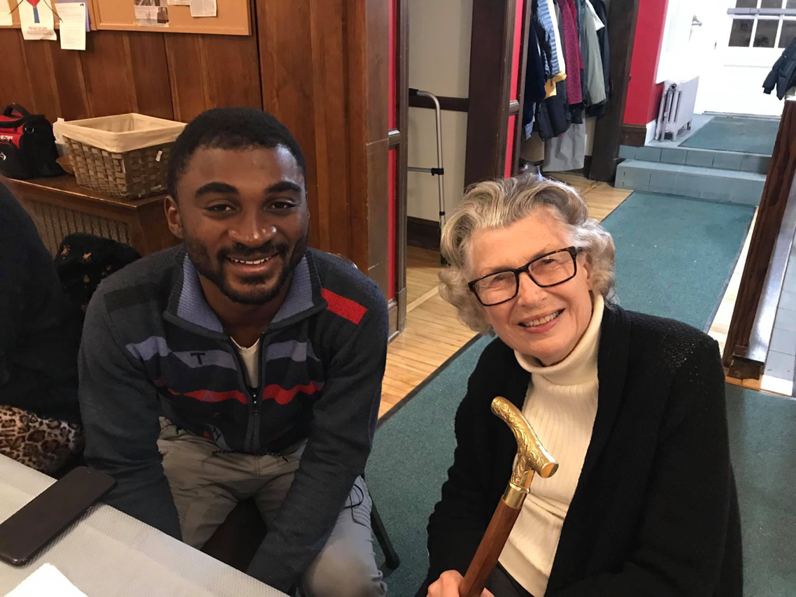

Vestry

The Vestry has taken up where we left off last year: working hard to ensure that St. Peter’s is a vibrant community of God’s children. This includes working to make The Key financially sound and working to have as much income as we have expenses. Although the Church is in the black, that is due not to current revenue but to a surplus from last year. Even though the gross income for the Key was a solid improvement from past years, its net income (gross minus expenses) still had The Key running in the red. Of course, that is not sustainable. Please let the Vestry know if you have any ideas for addressing this recurring issue.

Meanwhile, plans are coming along for renovating the Women’s bathroom. The committees that the Vestry reinvigorated last year are up and running. Assistance is still needed on these committees. Please let any Vestry or Rebecca know if you would like to serve on any of our committees: the Hospitality Committee; the Altar Guild; the Worship Committee; the Communications Committee; the Buildings, Gardens and Grounds committee; and the Finance Committee.

Thank you to all who serve God in this Church, in your family, this community and the world beyond.

Faithfully Yours.
Cynthia Maxwell Curtin

Our new Vestry:

Front row, L to R: Betsy Moore, Sandy Petroff, Rev. Rebecca Roberts

Back row, L to R: John Limmer, Tim McCay, Bob Conway, Suzanne Evans, Cynthia Maxwell-Curtin (Sr. Warden), McEwan van der Mendele (Jr. Warden)

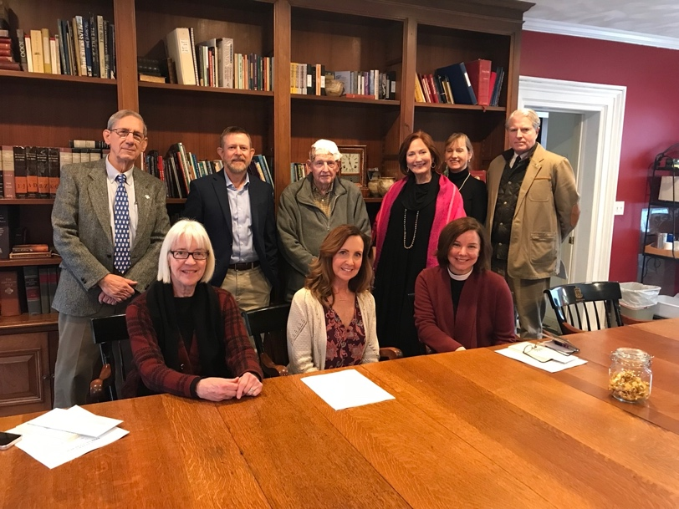

News of St. Peter’s and the Greater Community

News from the Key
While our church continues to search for its new executive director, Meredith and Dolli are doing a wonderful job managing The Key. The windows and merchandise are continuously being updated. If you haven’t been to the Key recently you should make a visit. The policies for consigning and donating items has been updated. There are always blue dot sales and social dollar racks, as well as lovely clothing, housewares, and even some furniture. The old original Key is now changed and provides a unique and really pleasant shopping experience, as well as providing grants to a variety of community organizations. If you have any questions or concerns regarding the future of The Key, please ask Rev Rebecca.

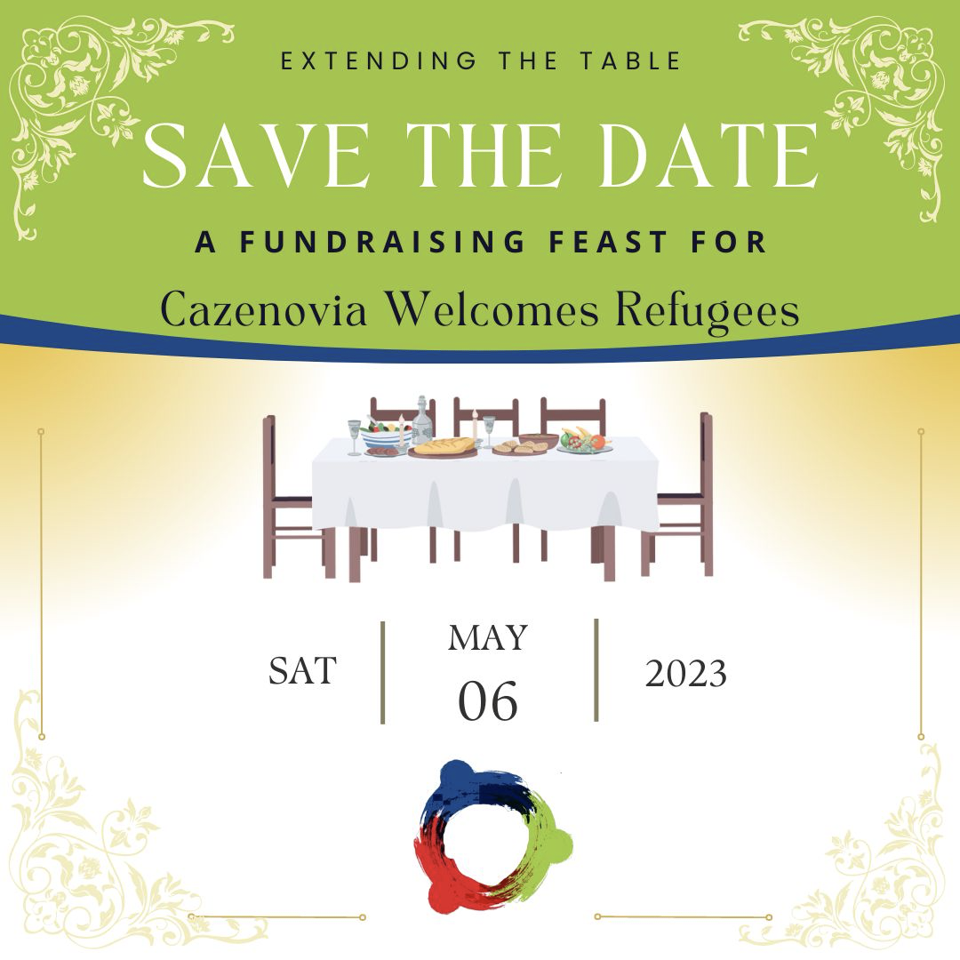

Extending the Table event to take place on May 6
Stay tuned for news about CWR's Extending the Table Dinner. The event will feature great company, food, and opportunities to support CWR's mission.
This event will take place at St. Peter’s Episcopal Church

During the month of March St. Peter's is collecting canned tuna for CazCares. Please consider putting a couple of cans into the donation basket in the Parish Hall. Thank you!

In March, CRIS, St. Peter’s Church, and the Cazenovia Public Library will begin hosting a series of 6 monthly presentations concerning issues that arise during aging and how to plan for them. Speakers will include Michael Brown, from the Brown Funeral Home, The Rev. Rebecca Roberts, Paul Curtin, and others. There will be panels and discussions concerning Hospice, care giving, legal matters, funeral planning, etc.
This series will take place on the 4th Monday of the months of, March, April, May, September, October, and November, from 10:00 to 12:00 noon at the Cazenovia Public Library (note that there are no meetings in June and July!)

Diocesan News

Did you know the Diocese makes regular book recommendations? The most recent ones are on the topic
How and Why We Care for Creation
Many of these books are available through the Cazenovia Public Library

Calendar

Events in March

1 6:30 pm Soup Supper and Book Discussion in the Parish Hall
2 10:00 am Bone Builders (Parish Hall)
5:30 pm Evening Prayer Service, Rite II
7:00 pm Choir Practice
5 10:00 am Sunday Service, followed by Coffee Hour and Lenten Series (Libr.)
6 10:00 am Bone Builders (Parish Hall)
8 6:30 pm Soup Supper and Book Discussion in the Parish Hall
7:00 pm Vestry meeting (Library)
9 10:00 am Bone Builders (Parish Hall)
5:30 pm Evening Prayer Service, Rite II
7:00 pm Choir Practice
12 10:00 am Sunday Service, followed by Coffee Hour and Lenten Series (Libr.)
13 10:00 am Bone Builders (Parish Hall)
5:00 pm Volunteer Day at the Friendship Inn
7:00 pm AA Meeting (Parish Hall)
15 6:30 pm Soup Supper and Book Discussion in the Parish Hall
16 10:00 am Bone Builders (Parish Hall)
5:30 pm Evening Prayer Service, Rite II
7:00 pm Choir Practice
19 10:00 am Sunday Service, followed by Coffee Hour and Lenten Series (Libr.)
3:00 pm Organ Concert with Organist Augustine Sobeng
20 10:00 am Bone Builders (Parish Hall)
22 6:30 pm Soup Supper and Book Discussion in the Parish Hall
23 10:00 am Bone Builders (Parish Hall)
5:30 pm Evening Prayer Service, Rite II
7:00 pm Choir Practice
26 10:00 am Sunday Service, followed by Coffee Hour and Lenten Series (Libr.)

Events in March (continued)

27 10:00 am Bone Builders (Parish Hall)
10-12 am CRIS series on Aging at the Cazenovia Public Library
29 6:30 pm Soup Supper and Book Discussion in the Parish Hall
30 10:00 am Bone Builders (Parish Hall)
5:30 pm Evening Prayer Service, Rite II
7:00 pm Choir Practice

__________________________________________________________________________________________

Copyright © 2023 St. Peter’s Episcopal Church, all rights reserved

Our mailing address is:
St. Peter’s Episcopal Church
10 Mill Street
Cazenovia, NY 13035
315-655-9063

Email us at:
parishoffice@stpeterscaz.org
Find us at:
www.stpterscaz.org

